** A**

**Project Report**

on

**PhobiaX: Revolutionizing Therapy with Virtual Reality**

submitted as partial fulfillment for the award of

**BACHELOR OF TECHNOLOGY**

**DEGREE**

SESSION 2024-25

in

**Computer Science and Information Technology**

By

Yadav Anurag Brijeshpratap(2100290110032)

Harsh Singh(2100290110061)

Khushboo Chaturvedi(2100290110074)

Shaiz Khan(2100290110151)

**Under the supervision of**

Mr. Deep Kumar

**KIET Group of Institutions, Ghaziabad**

Affiliated to

**Dr. A.P.J. Abdul Kalam Technical University, Lucknow**

(Formerly UPTU)

**May, 2025**

**DECLARATION**

We hereby declare that this submission is our own work and that, to the best of our knowledge and belief, it contains no material previously published or written by another person nor material which to a substantial extent has been accepted for the award of any other degree or diploma of the university or other institute of higher learning, except where due acknowledgment has been made in the text.

Signature

Name: Yadav Anurag Brijeshpratap

Roll No.: 2100290110032

Date: 13th  May, 2025

Signature

Name: Harsh Singh

Roll No.: 2100290110061

Date: 13th  May, 2025

Signature

Name: Khushboo Chaturvedi

Roll No.: 2100290110074

Date: 13th  May, 2025

Signature

Name: Shaiz Khan

Roll No.: 2100290110151

Date: 13th  May, 2025

**CERTIFICATE**

 This is to certify that Project Report entitled “**PhobiaX: Revolutionizing Therapy with Virtual Reality**” which is submitted by Yadav Anurag Brijeshpratap, Harsh Singh, Khushboo Chaturvedi, Shaiz Khan in partial fulfillment of the requirement for the award of degree B. Tech. in Department of Computer Science & Engineering of Dr. A.P.J. Abdul Kalam Technical University, Lucknow is a record of the candidates own work carried out by them under my supervision. The matter embodied in this report is original and has not been submitted for the award of any other degree.

**Mr. Deep Kumar Dr. Harsh Khatter**

**(Professor) (Dean, CSIT Department)**

**Date: 13/05/2025**

ACKNOWLEDGEMENT

It gives us a great sense of pleasure to present the report of the B. Tech Project undertaken during B. Tech. Final Year. We owe special debt of gratitude to Mr. Deep Kumar, Department of Computer Science and Information Technology, KIET Group of Institutions, Ghaziabad, for his constant support and guidance throughout the course of our work. His sincerity, thoroughness and perseverance have been a constant source of inspiration for us. It is only his continuous efforts that our endeavors have seen light of the day.

We also take the opportunity to acknowledge the contribution of Dr. Harsh Kahtter, Dean, Department of Computer Science and Information Technology, KIET Group of Institutions, Ghaziabad, for his full support and assistance during the development of the project. We also do not like to miss the opportunity to acknowledge the contribution of all the faculty members of the department for their kind assistance and cooperation during the development of our project.

We also do not like to miss the opportunity to acknowledge the contribution of all faculty members, of the department for their kind assistance and cooperation during the development of our project. Last but not the least, we acknowledge our friends for their contribution in the completion of the project.

Signature:

Name: Yadav Anurag Brijeshpratap

Roll No.: 2100290110032

Date: 13th May, 2024

Signature:

Name: Harsh Singh

Roll No.: 2100290110061

Date: 13th May, 2024

Signature:

Name: Khushboo Chaturvedi

Roll No.: 2100290110074

Date: 13th May, 2024

Signature:

Name: Shaiz Khan

Roll No.: 2100290110151

Date: 13th December, 2024

**ABSTRACT**

In today’s fast-paced world, mental health challenges like specific phobias are becoming increasingly common. Whether it’s the fear of heights (Acrophobia), darkness (Nyctophobia), or water (Aquaphobia), these intense fears can significantly disrupt a person’s daily life, emotional well-being, and ability to function normally. Although proven treatments like Cognitive Behavioral Therapy (CBT) are available, not everyone has equal access to them. The barriers are many—ranging from high treatment costs and the limited availability of trained therapists to the deep-rooted social stigma that still surrounds mental health issues.

To bridge this gap and make effective therapy more accessible, this project presents PhobiaX—a smart, tech-enabled solution designed to increase awareness, provide assessment, and deliver therapy for phobia-related conditions. PhobiaX is a unified system that leverages the combined strengths of virtual reality (VR), machine learning, and Android mobile technology to offer a fresh, engaging, and scalable approach to therapy.

At the heart of PhobiaX is an immersive VR experience created using the Meta Quest 2 headset. These virtual environments are carefully designed to simulate realistic phobia-inducing scenarios in a safe, controlled, and step-by-step manner. Users are gradually exposed to their fears in a virtual setting, helping them build resilience and reduce their anxiety over time—all without the risks or constraints of real-world exposure.

Supporting the VR therapy is an easy-to-use Android application that acts as a companion throughout the user's journey. This app serves multiple purposes: it educates users about different types of phobias, helps them navigate the therapeutic process, and enables them to track their progress. This ensures that users stay informed and motivated, and gives them a sense of control over their treatment.

Another key feature of PhobiaX is the integration of a machine learning algorithm trained on user-provided questionnaire data. This algorithm helps assess the severity of a user’s phobia both before and after therapy sessions. By analyzing patterns in user responses, the system can predict improvement trends and offer personalized insights, thereby making therapy more tailored and data-driven.

What sets PhobiaX apart from traditional approaches is its accessibility, affordability, and ability to offer therapy at the user’s own pace and comfort. Unlike conventional in-person sessions, which may involve waiting lists and travel, PhobiaX can be used anytime, anywhere. It provides a non-judgmental space for individuals to face their fears and heal, which is especially important for those who might be hesitant to seek help publicly.

This report dives deep into the design, development, and implementation of the PhobiaX system. It covers the technical architecture of its core components, the development methodologies used, and the potential real-world impact of this integrated therapy model. By blending immersive technology with intelligent assessment and mobile accessibility, PhobiaX aims to redefine how phobia treatment is delivered—making it more engaging, inclusive, and effective.

In essence, PhobiaX holds the potential to revolutionize mental health care for phobia sufferers by making evidence-based therapy widely available, deeply personalized, and far more approachable for people across different backgrounds and regions.

|  |  |
| --- | --- |
| **TABLE OF CONTENTS** | **Page No.** |
|  |  |
| CHAPTER 1 (INTRODUCTION)…………………………………………………. | 1 |
| 1.1. Introduction to Phobias and the Need for Innovative Treatments ……………... | 1 |
| 1.2. Project Description……………………………………………………………… | 3 |
| 1.2.1 PhobiaX:An Integrated Approach using Android, ML, and VR………….  1.3 Objectives and Scope of the project……………………………………………..  1.4 System Overview and Key Features……………………………………………..  1.5 Targeted Phobias.………………………………………………………………...  1.6 Challenges and Potential Impact…………………………………………………  1.7 Research Questions………………………………………………………………  CHAPTER 2 (LITERATURE RIVIEW)…………………………………………. | 5  6  8  10  11  12    13 |
| 2.1 The Role of Virtual Reality in Exposure Therapy……………………………… | 13 |
| 2.2 Machine Learning for Psychological Assessment.…........................................... | 18 |
| 2.3 Mobile Applications in Mental Health…….…………........................................  2.4 Related Work in Phobia Treatment Technologies………………………………  2.5 Summary of Relevant Literature…………………………………....................... | 18  19  20 |
| CHAPTER 3 (PROPOSED METHODOLOGY) ….................................................. | 22 |
| 3.1. PhobiaX System Architecture…………………………………………………..  3.2 Android Application Development……………………………………………...  3.3 VR Therapy Module Design and Implementation………………………………  3.4 Machine Learning Model for Phobia Assessment………………………………  3.5 Therapy Workflow and Evaluation Process……………………………………..  3.6 Technologies and Tools Used…………………………………………………… | 22  24  28  32  36  38 |
| CHAPTER 4 (RESULTS AND DISCUSSION).......................................................  4.1 User Interface and VR Environment Demonstrations………………………….  4.2 Machine Learning Model Performance and Assessment Results………………  4.3 Qualitative Observations and Key Findings……………………………………  4.4 Challenges and Limitations…………………………………………………….  4.5 Implications for Phobia Therapy………………………………………………. | 41  41  43  44  45  47 |
| CHAPTER 5 (CONCLUSIONS AND FUTURE SCOPE)....................................... | 48 |
| 5.1 Conclusion........................................................................................................... | 50 |
| 5.2 Future Directions and Potential Enhancements………………………………...  5.2.1 Integration of Physiological Data………………………………………….  5.2.2 Expansion to Other Phobias and Conditions………………………………  5.2.3 Advanced AI in Therapy Personalization…………………………………. | 51  51  52  53 |
|  |  |
| REFERENCES………………………………………………………………………. | 56 |
| APPENDIX………………………………………………………………………...... | 59 |
|  |  |
| Turnitin Report……………………………………………………………………..  Research Paper/patent Proof of communication,acceptance…….………………….. | 64  71 |
|  |  |
|  |  |
|  |  |
|  |  |
|  |  |
|  |  |
|  |  |

**LIST OF FIGURES**

|  |  |  |
| --- | --- | --- |
| **Figure No.** | **Description** | **Page No.** |
| 1.1  1.2  3.1  3.2  3.3  3.4  3.5  3.6  3.7 | Challenges in PhobiaX Solution  Architecture of PhobiaX  Proposed Workflow of PhobiaX  Mockup of key Android application screens  Virtual Environment for Social Phobia  Virtual Environment for Arachnophobia  Virtual Environment for Acrophobia  Pre and Post Comparision Evaluation Graph -1  Pre and Post Comparision Evaluation Graph -2 | 3  5  24  27  30  31  32  35  36 |

**LIST OF TABLES**

|  |  |  |
| --- | --- | --- |
| **Table. No.** | **Description** | **Page No.** |
| 2.1 | Literature Review | 15 |

**LIST OF ABBREVIATIONS**

VR Virtual Reality

CBT Cognitive Behavioral Therapy

ML Machine Learning

IOT Internet of Things

UI User Interface

GUI Graphical User Interface

ARET Augmented Reality Exposure Therapy

VRET Virtual Reality Exposure Therapy

HMD Head-mounted displays

SDK Software Development Kit

NLP Natural Language Processing

**CHAPTER 1**

**INTRODUCTION**

* 1. **Introduction to Phobias and Need for Innovative Treatment**

Phobias are more than just common fears—they are deeply rooted, often overwhelming responses to specific objects, situations, or environments that might not pose any real danger. Whether it's a fear of heights, darkness, or deep water, these reactions can feel very real and intense to those experiencing them. For many people, phobias aren’t just passing anxieties; they can interfere with daily life in serious ways. Avoiding certain situations, constantly worrying about potential triggers, or feeling isolated because of these fears can have a significant impact on a person's emotional and psychological health.

While it’s normal for children to go through phases of being afraid—like being scared of the dark or thunderstorms—most of these fears fade with time. But in many cases, especially when these fears persist into adulthood or intensify, they can evolve into clinical phobias that require professional attention and structured treatment.

Traditionally, one of the most effective methods to treat phobias has been Cognitive Behavioral Therapy (CBT). This form of therapy focuses on identifying negative thought patterns and gradually confronting the source of fear through methods like exposure therapy and systematic desensitization. In theory, CBT helps individuals build tolerance to their fears by safely experiencing them in controlled stages. However, the practical application of these therapies can be challenging for many people.

Access to therapy is still limited for a significant portion of the global population. Many individuals live in areas where mental health professionals are scarce or overbooked. Even in urban areas where help is more available, the high cost of repeated therapy sessions often puts effective treatment out of reach. Additionally, societal stigma around mental health continues to discourage people from seeking therapy, fearing judgment or misunderstanding from others. This stigma, combined with the emotional toll of the phobia itself, can leave people feeling stuck and unsupported.

Fortunately, modern technology is opening new doors in the field of mental health treatment. Over the last few decades, digital innovation has introduced more accessible and interactive forms of therapy. One such breakthrough is Virtual Reality (VR)—a technology that simulates real-world environments in a fully immersive and safe virtual space. VR offers a compelling alternative to traditional exposure therapy by letting users face their fears without ever leaving their homes or therapy centers.

What makes VR so promising is its ability to customize exposure. For example, someone with acrophobia (fear of heights) can begin by standing on a virtual balcony, gradually progressing to higher altitudes over time. Similarly, someone with nyctophobia (fear of darkness) or aquaphobia (fear of water) can be gently exposed to darker or deeper environments in a way that feels manageable and secure. Unlike real-world exposure, where variables can be hard to control, VR ensures consistency, safety, and a pace that suits the individual.

Not only does VR help reduce the risks associated with real-world exposure, but it also lowers the barrier to entry for therapy. People who may be too anxious or embarrassed to seek traditional help might feel more comfortable using a VR-based system, especially if it's paired with a supportive mobile app or home-based setup. With tools like VR headsets and mobile apps becoming more affordable and user-friendly, immersive therapy is becoming a practical reality for more people.

In summary, the combination of rising phobia cases and the limitations of conventional treatment methods highlights a growing need for innovative, accessible, and stigma-free solutions. By integrating VR into therapeutic practices, we can offer individuals a new way to understand, confront, and ultimately overcome their fears—on their own terms and in a way that respects their pace and privacy.

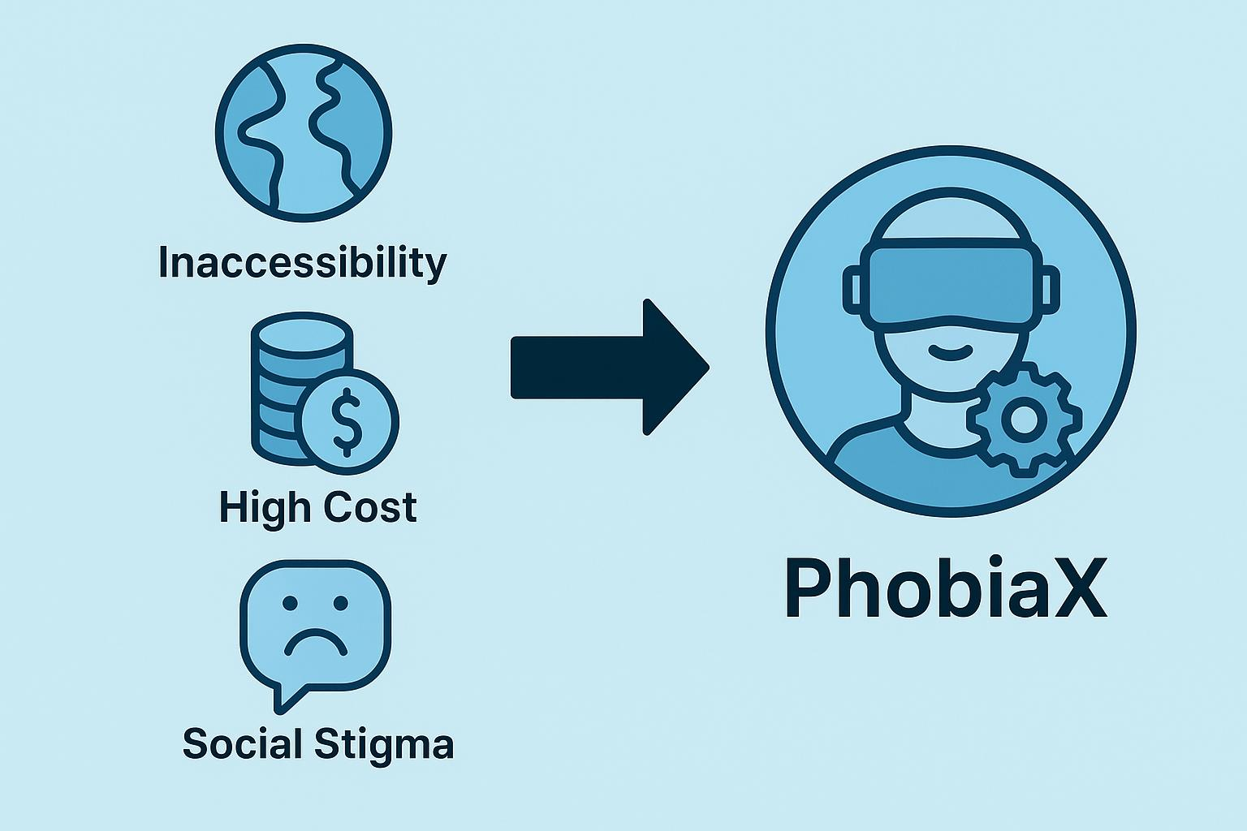

Figure 1.1 Challenges in PhobiaX solution

* 1. **PhobiaX: An Integrated Approach using Android, ML, and VR**

At the heart of the PhobiaX system is an innovative use of Virtual Reality (VR), designed to help individuals confront and gradually overcome their fears in a safe, immersive environment. Instead of relying solely on traditional therapy methods that may require confronting phobias in the real world—which can be intimidating or even unfeasible—PhobiaX offers a digital alternative that feels real but remains completely under the user's control.

The core idea is simple yet powerful: create virtual experiences that mirror the real-life situations that trigger phobic responses, such as standing on a high ledge for someone with acrophobia (fear of heights), being in a dark room for someone with nyctophobia (fear of darkness), or encountering deep water for someone with aquaphobia (fear of water). These virtual environments are accessed using the Meta Quest 2 headset, which allows users to fully immerse themselves in realistic simulations while staying physically safe and grounded. Using handheld controllers, individuals can interact with their surroundings in real time, moving through scenarios at a pace that suits their comfort level.

What makes this setup particularly effective is that it enables gradual exposure. Users aren't immediately thrown into the most intense version of their fear. Instead, they start small—maybe looking at a tall building or seeing a dark hallway—and build up to more challenging scenes as they gain confidence. This progressive approach mirrors traditional exposure therapy but does so in a way that feels more engaging, less risky, and far more flexible.

In addition to the VR therapy sessions, PhobiaX includes a robust Android mobileapplication, which acts as the companion tool for the entire system. A unique strength of PhobiaX lies in its integration of machine learning (ML) to personalize and improve therapy outcomes. Before and after each VR session, users are prompted to fill out brief questionnaires that capture their emotional state, perceived anxiety levels, and confidence in facing their fears. These responses are analyzed by a machine learning algorithm trained to detect patterns and predict the severity level of a user's phobia. Over time, as the system gathers more data, it becomes smarter and more accurate in evaluating user progress.

Together, the VR simulations, the mobile app, and the intelligent ML model create a comprehensive therapeutic ecosystem. PhobiaX not only helps people confront their fears but also empowers them with tools, insights, and motivation to reclaim control over their lives. Whether used independently or alongside traditional therapy, this system brings the future of mental health treatment closer to home, making effective phobia management more accessible, private, and user-centric than ever before.

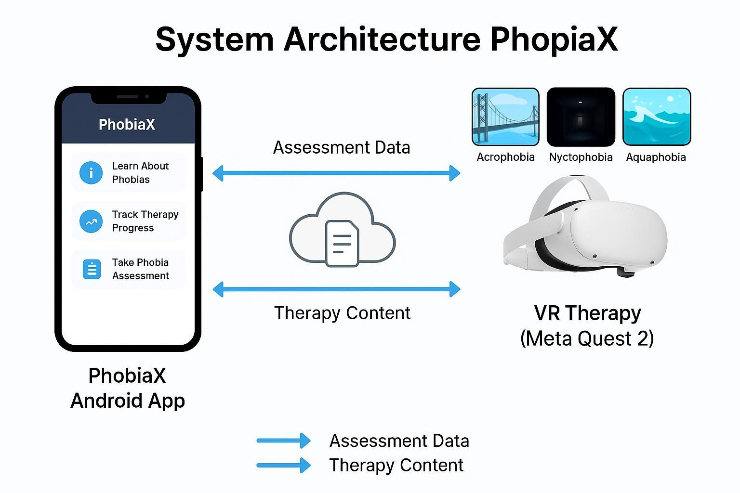

Figure 1.2 Architecture of PhobiaX

**1.2.1 PhobiaX: An Integrated Approach using Android, ML, and VR**

One of the most compelling strengths of PhobiaX lies in the seamless integration of Android mobile technology, machine learning, and virtual reality (VR)—a trio that works together to redefine how phobias are understood and treated. Each component plays a vital role in delivering a holistic and user-centric therapeutic experience.

The Android application acts as the user's personal gateway to the entire system. Designed with accessibility and simplicity in mind, it puts essential tools and information right at users’ fingertips. Whether someone wants to read up on the nature of their phobia, track their therapy sessions, or receive reminders and updates, they can do it all through an intuitive and familiar mobile interface. This ease of access ensures that users can stay engaged with their treatment journey without needing any specialized equipment or technical expertise.

On the analytical side, machine learning adds a layer of intelligence that goes beyond traditional therapy tools. Instead of relying solely on how users feel or what they report—which can sometimes be influenced by mood or perception—the system analyzes patterns in questionnaire responses before and after each therapy session. This allows the algorithm to objectively estimate the severity of the phobia and monitor how it changes over time. As users progress through therapy, the data collected helps personalize the experience, ensuring that treatment is both adaptive and responsive to individual needs.

Perhaps the most immersive aspect of PhobiaX is its use of virtual reality. VR brings the principles of exposure therapy to life by placing users in realistic, computer-generated environments that replicate their fears—but in a safe and controlled setting. Instead of facing their phobias in unpredictable real-world scenarios, users can build their confidence gradually, experiencing challenging situations step by step at their own pace. The sense of presence and realism that VR offers makes the therapeutic process more engaging and impactful, while eliminating the logistical and emotional barriers often associated with traditional in-person exposure therapy.

Together, this triad of technologies creates a unified, user-friendly system that is not only effective but also convenient and empowering. By bringing therapy into users’ hands, PhobiaX has the potential to make phobia treatment more accessible, personalized, and stigma-free, helping individuals face their fears with confidence—anytime, anywhere.

**1.3 Objectives and Scope of the Project**

The PhobiaX project was born from a vision to make phobia treatment more accessible, engaging, and effective by leveraging the power of emerging technologies. At its core, this initiative aims to bridge the gap between traditional therapeutic methods and modern digital solutions, offering individuals a supportive, data-driven pathway to manage and overcome their fears. The key objectives of this project are outlined below:

* To conceptualize and build an integrated digital ecosystem that brings together the strengths of Android mobile platforms, machine learning algorithms, and immersive virtual reality (VR) environments for a comprehensive approach to phobia awareness, assessment, and therapy.
* To design realistic and psychologically safe VR environments specifically crafted to help users confront and gradually desensitize their fears. Initial efforts are focused on three common phobias: Acrophobia (fear of heights), Nyctophobia (fear of darkness), and Aquaphobia (fear of water), with the aim to deliver progressive exposure in a controlled virtual setting.
* To implement a machine learning model that can intelligently evaluate users’ fear levels by analyzing responses from structured questionnaires. This model is tasked with measuring phobia severity both before and after therapy sessions, helping to quantify therapeutic outcomes and personalize user experiences.
* To develop an intuitive and user-friendly Android application that acts as the control center for users. The app offers educational material, access to therapy sessions, progress tracking features, and direct interaction with the assessment system, all within a clean and approachable interface.
* To explore the potential of PhobiaX as a transformative alternative to traditional therapy by evaluating its usability, accessibility, and scalability. The system aims to empower users by placing therapeutic tools in their own hands, reducing dependency on in-person sessions and breaking down social or financial barriers to treatment.

The scope of the PhobiaX project includes the end-to-end design, development, and initial testing of the entire system. The first phase of implementation is deliberately focused on the three selected phobias—acrophobia, nyctophobia, and aquaphobia—as they represent a range of common fears that can significantly disrupt daily life. These phobias were chosen based on their prevalence and the practicality of simulating them in virtual environments.

However, the architecture and design philosophy behind PhobiaX are inherently modular and scalable. This means that while the current version is limited to three phobias, future iterations of the system can be easily extended to support a broader range of fear-based disorders, including social phobia, claustrophobia, and more.

The primary focus of this report is to document the technical development, system architecture, and the rationale behind key design decisions, along with a preliminary evaluation of the system's functionality and user experience. While large-scale clinical validation falls outside the current scope, this version lays the groundwork for future studies and iterations aimed at improving mental health support through accessible technology.

**1.4 System Overview and Key Features**

The PhobiaX system is built as a unified platform that brings together three powerful components—an intuitive Android app, a smart machine learning assessment engine, and immersive virtual reality therapy modules. Each part of this system plays a distinct yet interconnected role in guiding users through their journey of understanding and overcoming their phobias in a structured and supportive way.

**1. Android Application**

At the heart of the user experience is a custom-built Android app that acts as a centralized hub for everything PhobiaX has to offer. Designed with user-friendliness in mind, the app provides:

* Educational content to help users better understand their fears and the science behind phobias.
* Access to therapy and assessment tools, allowing users to move smoothly through the therapy process at their own pace.
* Real-time progress tracking, so users can monitor their improvements over time.  
  The app ensures that users are never lost or overwhelmed, offering step-by-step guidance and a familiar mobile interface for managing their therapy sessions.

**2. Machine Learning-Based Assessment System**

Built using Streamlit and powered by a Random Forest Classifier, the assessment module introduces an intelligent, data-driven layer to the therapy process. Rather than relying solely on subjective feelings, this system analyzes user responses to specially designed pre- and post-therapy questionnaires. It then:

* Predicts the severity of the user’s phobia.
* Tracks therapeutic progress over multiple sessions.
* Provides personalized insights that can help tailor the treatment path to individual needs.

This approach not only adds objectivity to the therapy but also gives users tangible feedback, making their improvement measurable and motivating.

**3. Virtual Reality Therapy Modules**

Perhaps the most innovative aspect of PhobiaX lies in its Virtual Reality therapy environments, developed in Unity and deployed through Meta Quest 2 headsets. These modules are:

* Realistic and immersive, simulating everyday scenarios that trigger specific phobias like acrophobia (heights), nyctophobia (darkness), and aquaphobia (water).
* Designed for progressive exposure, starting with mild challenges and gradually increasing in intensity to help users confront their fears step by step.
* Controlled and safe, ensuring that while the experience feels real, users are never in any actual danger.

**Key Features of the PhobiaX System**

* Immersive VR Therapy: Highly detailed and customizable virtual environments replicate real-world fear triggers, enabling users to face them in a secure setting.
* Gradual Exposure: Therapy modules are built around a stepwise exposure model, allowing users to slowly adapt and reduce their fear response.
* Smart Assessment with Machine Learning: By analyzing patterns in user feedback, the system objectively measures progress and adapts to individual needs.
* Accessible and Friendly Interface: The Android app simplifies navigation, offers valuable insights, and makes therapy accessible anytime, anywhere.
* Continuous Progress Monitoring: Users can view how their anxiety levels change over time, fostering a sense of accomplishment and control.
* Safe and Supportive Environment: By avoiding real-world exposure, VR therapy ensures users feel secure as they tackle their phobias head-on.

**1.5 Targeted Phobias**

In its initial phase, PhobiaX is designed to target three of the most commonly reported and impactful phobias—acrophobia, nyctophobia, and aquaphobia. These specific fears were chosen because of their widespread occurrence and the strong potential for virtual reality therapy to provide safe, controlled, and effective exposure experiences.

* **Acrophobia (Fear of Heights)**: This phobia involves an intense fear of being in high places, such as rooftops, balconies, tall buildings, or bridges. Individuals with acrophobia may experience dizziness, panic, or even a sense of paralysis when exposed to heights. In PhobiaX, users are gradually exposed to increasing altitudes in a virtual setting, helping them build tolerance and reduce fear over time without ever leaving the ground.
* **Aquaphobia (Fear of Water):** Claustrophobia is the intense fear of confined or enclosed spaces, and it's more common than many realize. For individuals who experience it, being in small rooms, elevators, crowded public transport, or even MRI machines can trigger overwhelming feelings of anxiety or panic. This fear often leads to avoidance behaviors that can interfere with daily activities—whether it's refusing to use lifts, dreading airplane travel, or feeling trapped in packed spaces.
* **Aquaphobia (Fear of Water)**: Aquaphobia can take many forms, from fear of deep water and swimming to anxiety triggered by even shallow pools, lakes, or bathtubs. This fear often interferes with daily life and recreational activities. The VR modules in PhobiaX simulate calming and controlled water environments, allowing users to safely confront and manage their fear step by step.

By focusing on these three phobias, PhobiaX lays a strong foundation for demonstrating how immersive technology can be used to make therapy more engaging, accessible, and impactful. These initial modules also help set the stage for future expansion to other phobias using the same core framework.

**1.6 Challenges and Potential Impact**

The journey of developing PhobiaX is both exciting and complex. While the potential impact is immense, the process comes with its fair share of challenges. Crafting virtual environments that not only look realistic but also evoke the specific emotional triggers associated with phobias requires thoughtful design and psychological insight. It’s not just about creating a virtual space—it’s about capturing the nuances of fear in a way that feels authentic but remains safe and supportive for the user.

Integrating the different components of the system—the Android app, machine learning backend, and VR headset—adds another layer of technical difficulty. Ensuring these elements work together smoothly is essential for delivering a seamless and effective therapeutic experience. Moreover, it's important to recognize that the effectiveness of virtual reality therapy can differ from person to person. Some users may respond quickly, while others may need more time and a more personalized approach. Continued research and refinement are necessary to understand how best to tailor the therapy for different individuals.

Despite these hurdles, PhobiaX offers real promise. By combining modern technology with evidence-based therapy principles, it presents a fresh alternative to conventional mental health treatments. It reduces the stigma around seeking help, makes therapy more accessible—especially in remote or underserved areas—and lowers the financial burden that can come with repeated sessions.

What sets PhobiaX apart is its machine learning-driven assessment, which adds a layer of objectivity that’s often missing in traditional treatment. By tracking progress and phobia severity through data, users and clinicians alike can make informed decisions about how to move forward. Ultimately, the goal of PhobiaX is simple yet powerful: to help people take control of their fears and reclaim parts of their life that anxiety once held back.

**1.7 Research Questions**

This project aims to explore and answer several important research questions that lie at the heart of modern, tech-driven mental health solutions:

* How can virtual reality experiences be designed in a way that effectively recreates fear-inducing situations while still providing a sense of safety and control? Understanding how to strike the right balance is key to helping individuals gradually confront and manage their fears without feeling overwhelmed.
* Can machine learning models reliably assess the severity of a person’s phobia using responses from psychological questionnaires? More importantly, can these models help monitor progress over time, providing objective insights into how well a person is responding to therapy delivered through virtual environments?
* Is it possible to develop a mobile application that brings everything together—education, assessment, and immersive therapy—into one cohesive and user-friendly platform? The goal is to make the treatment process intuitive, engaging, and easily accessible for users, even outside of traditional clinical settings.
* What are the real-world benefits and limitations of combining Android, machine learning, and VR technologies into a single treatment tool like PhobiaX, especially when compared to more traditional forms of therapy? We’re particularly interested in how this integrated approach might improve accessibility, personalization, and overall engagement for people dealing with specific phobias.

By posing these questions, this chapter sets the stage for understanding not only the problem of phobias but also the innovative and technology-driven approach that PhobiaX proposes to address them. The chapters that follow will dive deeper into the current body of research, the methods used to develop and implement PhobiaX, the outcomes of our initial testing, and the exciting possibilities for where this project could go in the future.

**CHAPTER 2**

**LITERATURE REVIEW**

**2.1 The Role of Virtual Reality in Exposure Therapy**

Virtual Reality Exposure Therapy (VRET) is gaining recognition as a transformative approach in treating anxiety disorders—especially phobias. What makes it so effective is its ability to place individuals in lifelike, immersive environments where they can safely confront their fears. Unlike traditional exposure therapy, which can be difficult to set up or emotionally overwhelming, VRET offers a controlled and gradual way to face these triggers, simulating real-world situations without the actual risks. The sense of "being there" in virtual reality is powerful enough to evoke genuine emotional reactions, helping users gradually become less sensitive to their fears through repeated exposure.

A comprehensive review by researchers **Ghalda Albakri, Rahma Bouaziz, Kammoun, and others (2022)** looked into the effectiveness of both Virtual Reality Exposure Therapy and Augmented Reality Exposure Therapy (ARET). Their findings were promising—these tech-based approaches showed strong results across different types of phobias, often rivaling traditional in-vivo (real-life) exposure techniques. They did note, however, that encouraging users to embrace this technology remains a crucial step toward broader clinical adoption.

Another study by **Ruben Freitas, Vitor Hugo Silva Velosa, and Pedro Campos (2021)** also took a deep dive into the potential of VRET. They emphasized several benefits, such as reducing the time needed for therapy sessions, lowering treatment costs (for example, for individuals with a fear of flying), and allowing therapists to create consistent and repeatable scenarios. One of VRET’s biggest advantages is the sense of safety it provides—patients can face their fears without any real-world danger. The researchers also pointed out that repetitive exposure is key to reducing fear responses, and VR makes it much easier to deliver this in a structured way. Head-mounted displays (HMDs) were highlighted as a practical and cost-effective choice in clinical use. Overall, their review confirmed that VRET is just as effective as traditional methods in lowering anxiety, fear, and avoidance, while offering added flexibility and accessibility.

Table 2.1. Shows the summary of key literature on VR and related technologies in phobia treatment

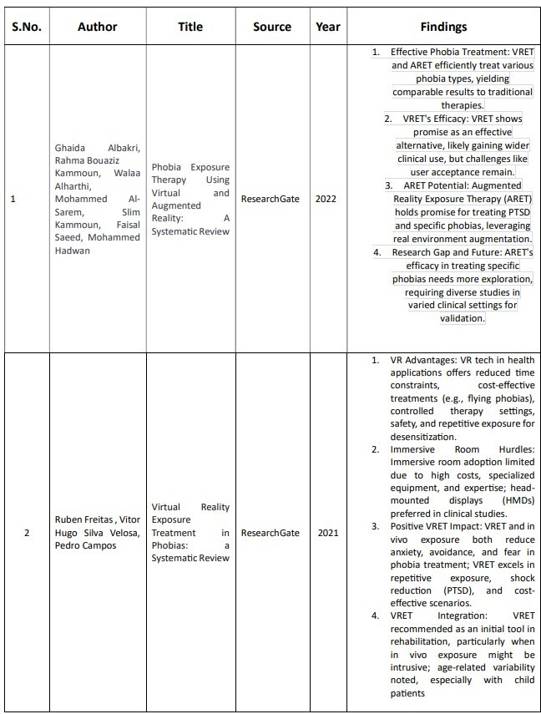

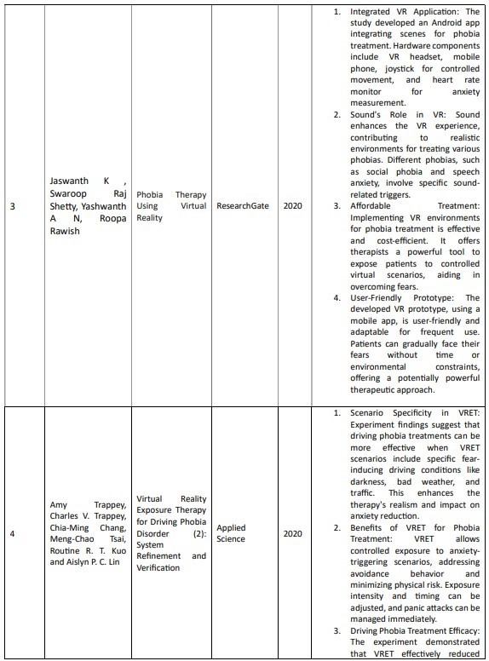

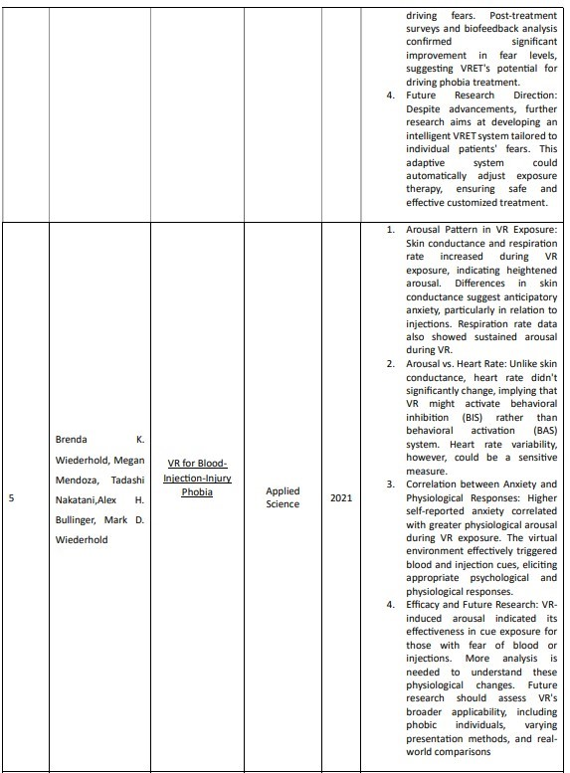

**2.2 Machine Learning for Psychological Assessment**

Machine learning (ML) is increasingly playing a vital role in improving how psychological conditions are assessed and treated. By processing large sets of data—ranging from behavioral patterns to physiological signals and self-reported answers—ML algorithms can uncover hidden trends and make predictions that support mental health professionals in diagnosis, gauging severity, and monitoring progress. This technology offers a data-driven approach that enhances both accuracy and efficiency in mental health care.

Although many existing studies haven’t directly focused on using machine learning for initial phobia assessments, the PhobiaX project is a step in that direction. It integrates ML to evaluate phobia severity using responses from pre- and post-therapy questionnaires. Drawing on broader applications of AI in mental health, it’s reasonable to suggest that ML models—like classification or regression algorithms—can be trained to recognize patterns in questionnaire responses and categorize individuals based on the intensity of their phobia (such as mild, moderate, or severe).

Beyond the initial assessment, machine learning proves useful in tracking therapeutic progress. By analyzing how an individual’s questionnaire responses change over time, ML can provide objective indicators of improvement or stagnation. This not only supports more personalized treatment plans but also adds a layer of measurable insight that traditional methods might miss.

**2.3 Mobile Applications in Mental Health**

Mobile applications have opened up new possibilities in the field of mental health by offering support and interventions that are both accessible and convenient. These apps can educate users about mental health conditions, offer practical self-help tools, track symptoms over time, and in some cases, even connect users with therapists. When it comes to treating phobias, mobile apps have the potential to go beyond basic support—they can become a personal therapy assistant, offering users immediate access to coping strategies, educational resources, and even exposure exercises through technologies like augmented or virtual reality.

A study conducted by **Jaswanth Swaroop Raj Shetty, Yashwanth AN, and Rawish Roopa** in 2020 showcases an innovative approach in this direction. They developed an Android application integrated with virtual reality, designed specifically for phobia treatment. Their prototype demonstrated how smartphones, when paired with VR headsets, can deliver immersive exposure therapy experiences right from the palm of a user's hand. The mobile app featured a simple and intuitive interface, making it easy for users to navigate therapy scenarios and engage with them meaningfully.

What made their approach even more effective was the inclusion of a joystick for movement control, which gave users a greater sense of involvement and control within the virtual environment—key elements for successful exposure therapy. They also integrated a heart rate monitor to track users' physical responses during the sessions, providing real-time feedback on anxiety levels. This thoughtful combination of tools illustrates the real potential of mobile platforms to deliver engaging, flexible, and scalable phobia treatments in a way that fits into people’s daily lives.

**2.4 Related Work in Phobia Treatment Technologies**

Several studies have explored the integration of Virtual Reality (VR) with mobile platforms, particularly in the context of treating phobias. One of the foundational studies in this area is by Shetty et al. (2020), which laid the groundwork for the use of VR in phobia treatment.

In a similar vein, Amy Trappey and colleagues (2020) looked into using Virtual Reality Exposure Therapy (VRET) for treating driving phobia. Their research highlighted that VRET's effectiveness can be greatly improved by customizing the virtual environments to match specific situations that trigger fear. For example, by creating VR scenarios that simulate driving at night, in bad weather, or during heavy traffic, therapists can target the precise sources of anxiety for individuals with driving phobia. This focus on tailoring VR environments to fit the unique aspects of each phobia is something that's central to the design of the VR modules in the PhobiaX project. Additionally, Trappey's team also explored the potential of using biofeedback, such as physiological data, to enhance the therapeutic process. This could be an exciting direction for future developments in PhobiaX.

Meanwhile, Brenda K. Wiederhold and her team (2021) studied the use of VR to treat blood-injection-injury phobia. In their research, they observed participants' physiological responses—such as increases in skin conductance and respiration rate—when exposed to virtual cues like blood and injections. These reactions mirrored the anxiety typically seen in real-life phobias, making VR a valid tool for exposure therapy. The correlation between participants' reported anxiety levels and their physiological responses further emphasized that VR can trigger authentic fear reactions, reinforcing its ecological validity as a method for phobia treatment.

These studies collectively highlight the potential of VR to create personalized, immersive environments that mimic real-life triggers, making it a powerful tool in phobia treatment.

**2.5 Summary of Relevant Literature**

The reviewed literature highlights the growing role of technology in assessing and treating phobias, showing how innovations like Virtual Reality (VR) are becoming increasingly valuable in this field. VR has proven to be a powerful tool for exposure therapy, offering a controlled and safe environment where tailored, repeatable scenarios can be created to help individuals confront their fears. By integrating mobile apps, these therapies become even more accessible and user-friendly, allowing for psychoeducation, managing therapy sessions, and possibly linking with VR experiences for a more comprehensive treatment approach.

While machine learning’s direct role in diagnosing phobias is still in its early stages, there is clear potential for it to analyze data from questionnaires and physiological responses. This could help track progress, personalize treatment, and make therapy even more effective. The importance of creating VR environments that are specific to each phobia and using physiological feedback to enhance therapy outcomes is becoming increasingly evident in related research.

The PhobiaX project aims to push this forward by combining the strengths of Android mobile technology, machine learning-based assessments, and immersive VR. The goal is to create a holistic, accessible system for raising awareness about specific phobias, assessing them, and providing therapy, making a meaningful contribution to the future of phobia treatment.

**CHAPTER 3**

**PROPOSED METHODOLOGY**

**3.1 PhobiaX System Architecture**

The PhobiaX system is thoughtfully designed with a modular architecture that integrates three key components to create a seamless and comprehensive experience for users dealing with phobias. These components include the Android Application Module, the Machine Learning Assessment Module (hosted on Streamlit), and the Virtual Reality Therapy Module (developed using Unity for the Meta Quest 2 headset).

At the heart of the PhobiaX system is the **Android Application Module**, which acts as the primary point of interaction for the user. This module offers a user-friendly interface where individuals can access valuable educational resources about different phobias, such as acrophobia (fear of heights), nyctophobia (fear of the dark), and aquaphobia (fear of water). The app's initial phase provides in-depth information on these phobias, helping users understand their fears better. Additionally, the app allows users to complete pre- and post-therapy questionnaires. Once completed, these responses are securely transmitted to the Machine Learning Assessment Module for further analysis. Beyond this, the Android application also serves as a gateway to the Virtual Reality Therapy Module. After users select a specific therapy for their phobia, the app triggers the corresponding VR experience on a connected Meta Quest 2 headset. Furthermore, the app displays the results of the phobia severity assessments generated by the Machine Learning Module, offering users the ability to track their progress and improvements over time.

The **Machine Learning Assessment Module**, hosted on Streamlit, plays a crucial role in processing the questionnaire data submitted by the user. This module is powered by a trained Random Forest Classifier model, which analyzes the responses to predict the user’s current level of phobia severity. Once the analysis is completed, the results are sent back to the Android app for display. Streamlit’s web interface makes it easy to deploy and interact with the machine learning model, ensuring that this component is both efficient and accessible for the project.

The **Virtual Reality Therapy Module**, built using the Unity 3D game engine and deployed on the Meta Quest 2 headset, offers immersive and controlled environments for exposure therapy. Each targeted phobia—acrophobia, nyctophobia, and aquaphobia—has its own dedicated VR scenario designed to help users gradually face their fears in a safe and controlled manner. With the help of the Meta Quest 2 controllers, users can actively interact with the virtual environments, navigating through different levels of exposure to their fears. This immersive experience is designed to be both engaging and effective in helping individuals confront and manage their phobias. The VR module also communicates with the Android app, enabling the therapy sessions to be initiated seamlessly. In future updates, the system might even track user performance data, further enhancing the overall therapy experience.

The user journey in the PhobiaX system begins with the Android app, where users are introduced to information about their phobia and complete an initial assessment. Based on their assessment results and therapy preferences, they proceed to the Virtual Reality Therapy Module for the exposure sessions. After completing the VR therapy, users are invited to take a follow-up assessment through the app, which helps them track their progress and see the improvements they’ve made. This interactive flow ensures that the experience is not only educational but also personalized, engaging, and accessible, empowering users to take control of their phobia treatment in a way that feels both manageable and effective.

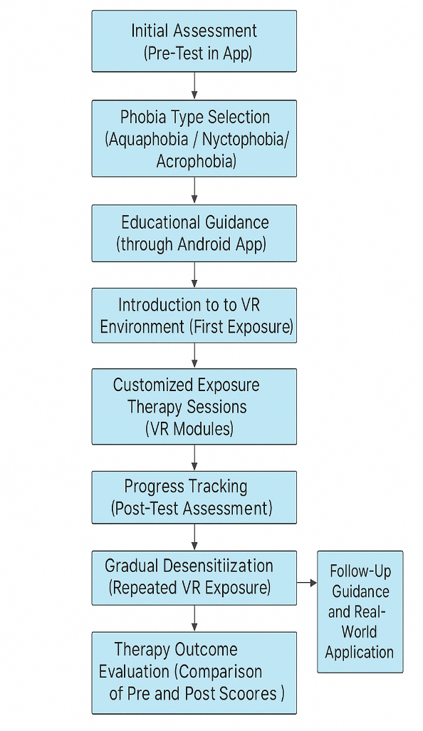

Figure 3.1 Proposed Workflow of PhobiaX

**3.2 Android Application Development**

The Android application for PhobiaX was developed with a strong focus on user-friendliness and accessibility, understanding that people dealing with phobias can often feel overwhelmed by complicated or confusing interfaces. With this in mind, the app features a simple, intuitive design that prioritizes clear navigation and concise information, making it easy for users to engage with the content and tools.

The User Interface (UI) Design is structured around a multi-screen architecture that ensures a smooth and organized experience. The home screen provides an overview of the app’s core features, including quick access to information about different phobias, the initial assessment questionnaire, and the VR therapy modules. Dedicated pages for each phobia—acrophobia (fear of heights), nyctophobia (fear of the dark), and aquaphobia (fear of water)—give users detailed insights into their specific fear, common symptoms, and how VR exposure therapy can be used to address them. The questionnaire interface is straightforward and user-friendly, presenting pre- and post-therapy questions in an easy-to-answer format that minimizes stress and helps users provide accurate responses. The results screen displays the phobia severity score generated by the machine learning model, with a simple visual graph that tracks the user’s progress, comparing pre- and post-therapy scores. Finally, the therapy selection screen lets users choose the VR therapy module tailored to their specific phobia.

The Key Functionalities of the Android application are designed to guide users through their phobia treatment journey effectively:

* **Phobia Education**: The app provides clear, understandable information on acrophobia, nyctophobia, and aquaphobia, helping users become more aware of their fears and the treatment options available to them.
* **ML-Based Assessment Access**: Users can complete the pre- and post-therapy questionnaires directly within the app. The collected data is then sent to the Streamlit server for analysis by the trained Random Forest Classifier, helping to assess the severity of their phobia.
* **VR Therapy Integration (Conceptual)**: While the actual VR therapy control is part of a future phase, the app currently includes a section where users can select the VR therapy module for their specific phobia. In a fully integrated system, this section would enable users to initiate the corresponding VR experience and provide instructions on how to use the Meta Quest 2 headset and controllers during therapy sessions.
* **Assessment Results Display**: The app clearly presents the results of the phobia severity assessment, allowing users to track their anxiety levels and see how their phobia severity has changed after completing VR therapy.
* **Progress Tracking (Basic)**: The app provides a simple comparison of pre- and post-therapy assessment scores, giving users a visual indication of their progress. In future versions, this feature could be expanded to include detailed tracking, such as session-by-session anxiety ratings or milestones achieved.

The development of the Android application took place in Android Studio, the official IDE for Android development, using Kotlin as the primary programming language. Kotlin was chosen for its conciseness, safety features, and compatibility with Java, ensuring a modern and efficient development process. The app’s UI was designed with XML layout files and implemented using Android Jetpack libraries, offering a robust and contemporary user experience that aligns with the latest Android standards.

In summary, the PhobiaX Android app is designed to be simple, intuitive, and effective, providing users with the tools they need to understand their phobia, assess its severity, engage with VR therapy, and track their progress in overcoming their fear—all through a seamless and supportive experience.

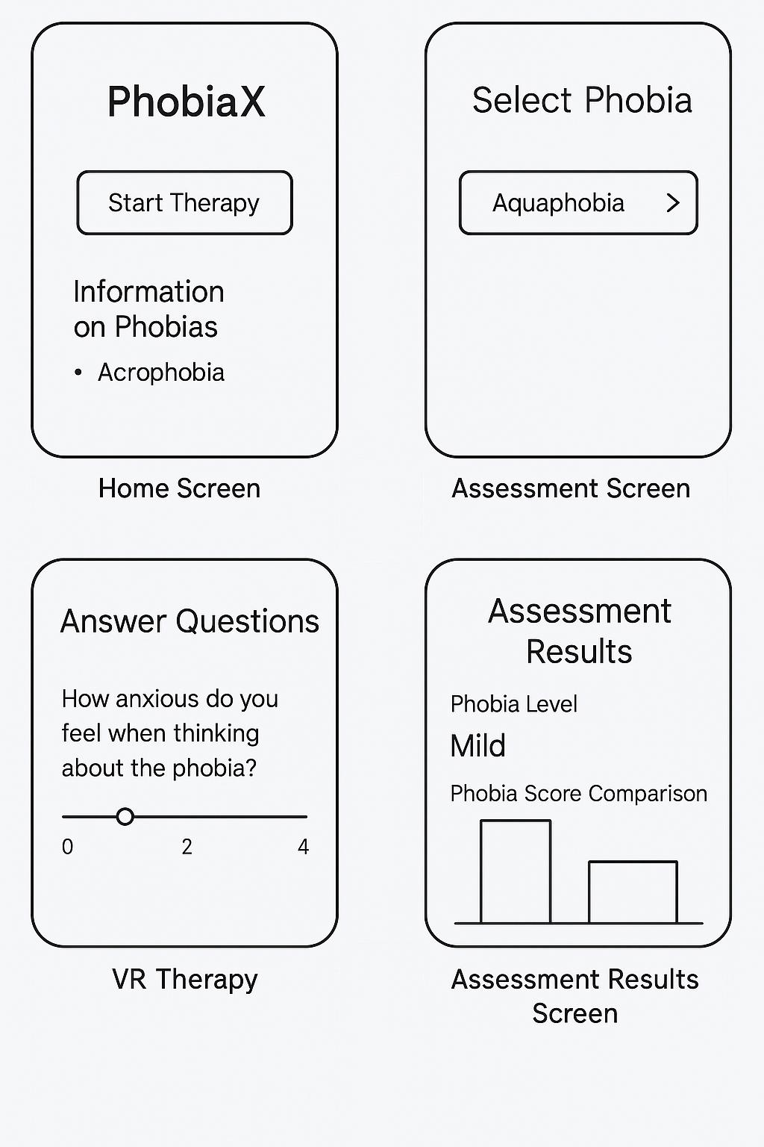

Figure 3.2 Mockup of key Android application screens

**3.3 VR Therapy Module Design and Implementation**

The Virtual Reality Therapy Modules for PhobiaX were carefully designed and developed using the Unity 3D game engine to create immersive, controlled environments that simulate fear-inducing scenarios for acrophobia, nyctophobia, and aquaphobia. The Meta Quest 2 headset was selected for its standalone nature, user-friendly design, and high-quality visual and spatial audio capabilities, which enhance the feeling of presence and realism during therapy sessions.

**Environment Design:**

* Aquaphobia Environment: This module creates a realistic simulation of a swimming pool, offering a range of depths from shallow wading areas to deeper sections. Users can interact with the water, hearing sounds like splashing or gentle waves. An optional scenario featuring a calm lake or ocean could be included, allowing for different experiences of water-related fears. The design encourages gradual exposure, starting with simply observing the water and advancing to virtual immersion and interaction.
* Nyctophobia Environment: The nyctophobia module simulates environments like a bedroom or living room, where the lighting can be adjusted. Users begin with dim lighting and progress to complete darkness. To evoke the feeling of unease that comes with the fear of the dark, subtle ambient sounds like distant wind or creaking floorboards are included. The user’s exposure to darkness increases gradually, possibly with tasks that require them to act in low-light conditions, helping them build confidence and reduce anxiety.
* Acrophobia Environment: This module takes users through different height scenarios, such as standing on a low balcony with a secure railing, riding in a glass elevator ascending a tall building, and standing on a high platform with panoramic views. The virtual environments are carefully designed to simulate the sensation of height, starting from safe, low altitudes and gradually increasing. The ground below appears distant, and the wind can be felt through subtle audio and visual cues, contributing to a highly immersive experience.

**Gradual Exposure Levels:**

Each of these environments is structured with multiple levels, allowing users to gradually increase their exposure and work through their fear step by step:

* Aquaphobia:
  + Level 1: Observing the pool from a safe distance.
  + Level 2: Standing at the edge and dipping a foot into the water.
  + Level 3: Walking into the shallow end.
  + Level 4: Fully immersing in the deeper water.
* Nyctophobia:
  + Level 1: A dimly lit room with visible objects.
  + Level 2: Reduced lighting, with outlines of objects barely visible.
  + Level 3: Near darkness, with minimal visibility.
  + Level 4: Complete darkness, relying on other senses like sound and touch.
* Acrophobia:
  + Level 1: Standing on a low, stable platform.
  + Level 2: Standing on a balcony with a secure railing.
  + Level 3: Riding in a slowly ascending elevator with glass walls.
  + Level 4: Standing on a high platform with a clear, open view of the ground far below.

**User Interaction and Control:**

Users interact with these environments using the Meta Quest 2 controllers, which allow for intuitive navigation through joystick movement or teleportation. Interaction with virtual elements, such as touching water, turning on a virtual light switch, or looking over the edge of a balcony, is made possible with the controllers. These controllers also provide a way for users to signal their anxiety levels—such as pressing a button or making a gesture—which could eventually be used for adaptive therapy in future updates.

The progression through different levels is flexible, either advancing automatically based on time or therapist input in guided sessions, or user-initiated when they feel ready to move on to the next level. This gives users control over their pace and ensures they can progress at a level that feels comfortable to them.

**Development and Technology:**

The VR Therapy Modules were built using Unity3D, a versatile game engine that allows for creating rich, interactive 3D experiences. The behavior of virtual objects, user interactions, and the flow of therapy sessions were scripted in C#, which provides the flexibility to customize the experience. The Meta Quest 2’s SDK was integrated into Unity, unlocking the headset’s advanced features like head and hand tracking, ensuring smooth, accurate tracking of the user’s movements and a fully immersive experience.

Overall, the PhobiaX VR Therapy Modules aim to provide users with a safe, controlled environment to confront and overcome their fears, gradually building confidence and reducing anxiety through immersive exposure therapy. The use of cutting-edge technology ensures that each user’s experience is both engaging and therapeutic, ultimately helping them take significant steps toward overcoming their phobias.

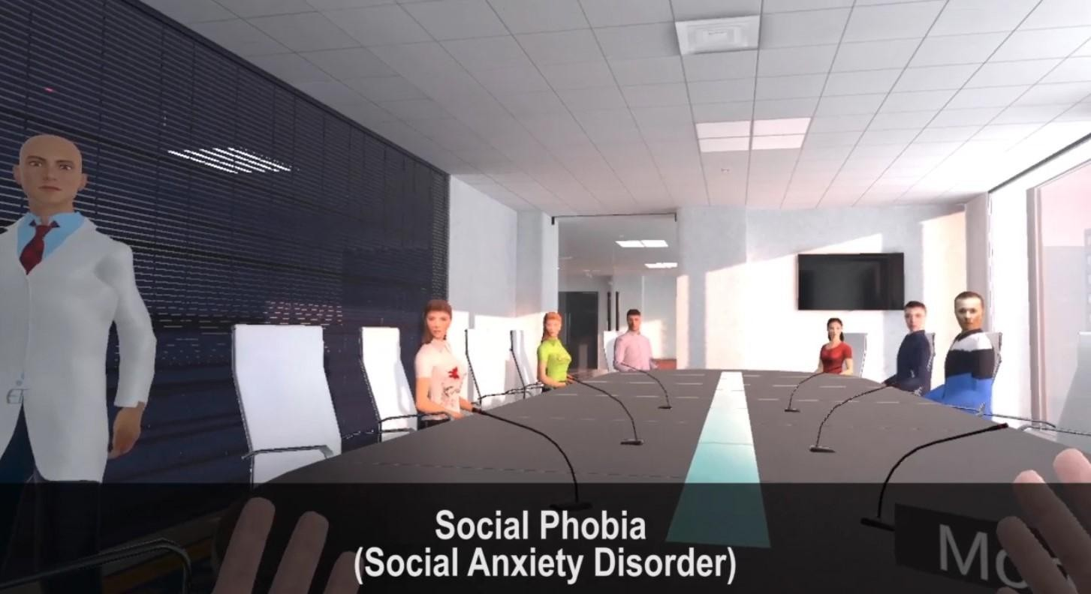

Figure 3.3 Virtual Environment for Social Phobia

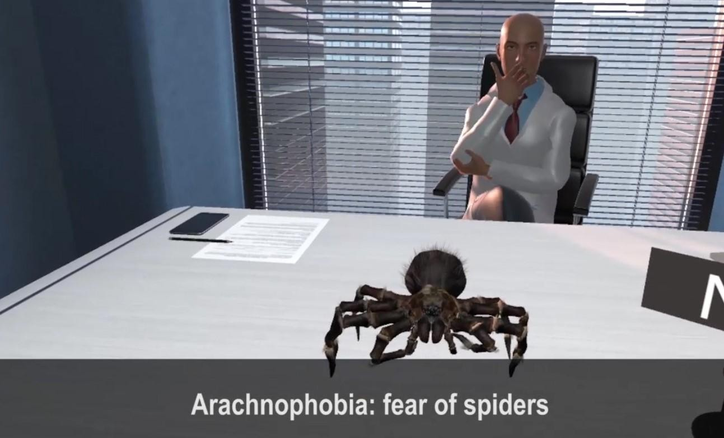

Figure 3.4 Virtual Environment for Arachnophobia

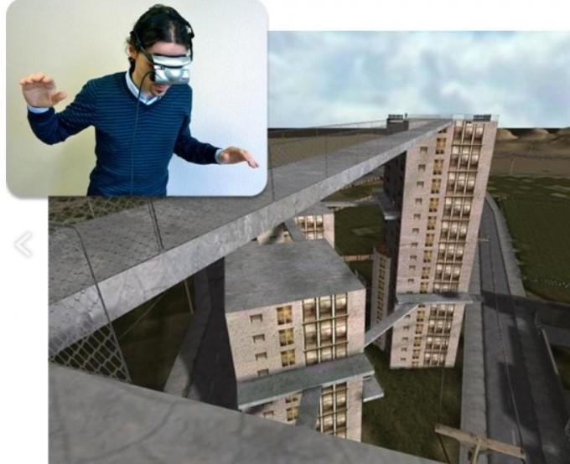

Figure 3.5 Virtual Environment for Acrophobia

**3.4 Machine Learning Model for Phobia Assessment**

The Machine Learning Model for PhobiaX is at the heart of providing data-driven, objective assessments of phobia severity. For this project, we opted for a Random Forest Classifier as the main algorithm because of its robustness, ability to handle complex relationships in data, and its interpretability, especially when it comes to understanding which features are most important in predicting phobia severity.

**Data Collection and Preprocessing (Simulated):**

Due to the constraints of the project, we created a simulated dataset with pre- and post-therapy questionnaire responses. This dataset includes hypothetical questions aimed at assessing symptoms and avoidance behaviors related to specific phobias, like acrophobia, nyctophobia, and aquaphobia. Each question was designed with a Likert scale (from 1 to 5, where 1 means "Not at all" and 5 means "Very much") to capture the intensity of the user's feelings. Based on predefined criteria, we labeled the data with different phobia severity levels (e.g., Low, Medium, High).

During the data preprocessing phase, we applied several techniques to ensure the data was ready for training the model. This included encoding categorical responses (where necessary), handling missing values (by filling them with the mean, median, or a constant), and scaling numerical features to ensure the model would perform well.

**Model Selection (Random Forest Classifier):**

The Random Forest Classifier was chosen because it is an ensemble learning method that works well with both categorical and numerical data. This algorithm is especially good at avoiding overfitting, as it builds multiple decision trees and averages their predictions. It also provides valuable insights into feature importance, showing which questionnaire items are most predictive of phobia severity. During training, the Random Forest algorithm constructs a number of decision trees, and for classification tasks, it takes the majority vote from all trees to determine the outcome.

**Model Training and Evaluation (Simulated):**

We split the simulated dataset into training (80%) and testing (20%) sets. Using the scikit-learn library in Python, the Random Forest Classifier was trained on the training data. We fine-tuned the model’s hyperparameters, such as the number of trees and maximum depth of the trees, using techniques like cross-validation to ensure the best performance.

Once trained, we evaluated the model’s performance using common classification metrics:

* Accuracy: How often the model made correct predictions.
* Precision: The ability of the model to avoid false positives.
* Recall: The model’s ability to identify all instances of phobia.
* F1-Score: A balance between precision and recall, especially useful when dealing with imbalanced classes.

To get a clearer picture of the model’s performance across different levels of phobia severity, we also generated a confusion matrix, which visualized how well the model predicted each severity level.

**Deployment on Streamlit:**

Once the model was trained and evaluated, it was deployed using Streamlit, a Python library that simplifies creating interactive web applications for data science. A basic web interface was designed with Streamlit, allowing users to fill out the pre- and post-therapy questionnaire. When a user submits their responses (either directly through the web interface or via the Android app), the input data is sent to the trained Random Forest model, which then predicts the phobia severity level.

The result is displayed on the Streamlit web page, providing immediate feedback to the user. This web application functions as the backend of the PhobiaX system, while the Android app serves as the frontend, where users can input their data and view the results.

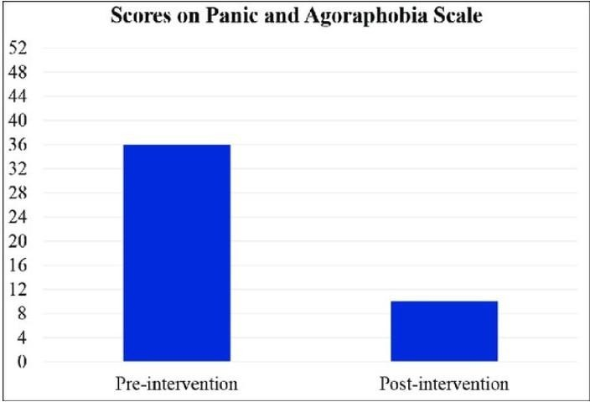

Figure 3.6 Pre and Post Comparision Evaluation Graph -1

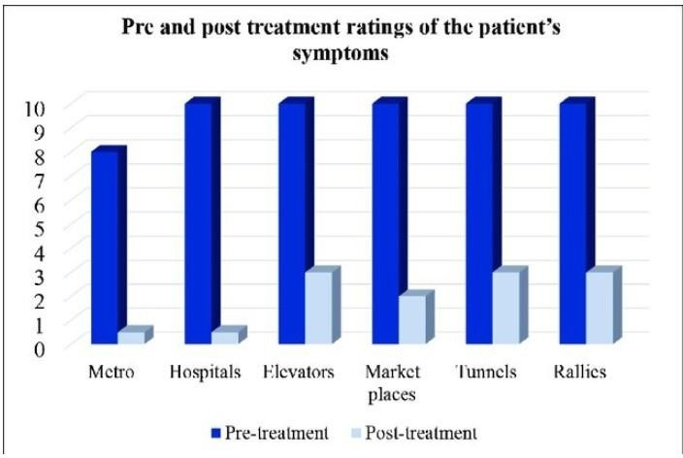

Figure 3.7 Pre and Post Comparision Evaluation Graph -2

**3.5 Therapy Workflow and Evaluation Process**

The therapy workflow for the PhobiaX system is designed with the user in mind, aiming to provide a smooth, progressive experience for those seeking to overcome their phobias. Here’s how it works:

**1. Pre-Assessment:**

When a new user opens the PhobiaX Android app, they begin by completing a standardized questionnaire. This questionnaire is tailored to assess their fear and avoidance behaviors related to the specific phobias being targeted, such as acrophobia (fear of heights), nyctophobia (fear of the dark), or aquaphobia (fear of water). Once the user submits their responses, the data is (theoretically) sent to the Machine Learning Assessment Module hosted on Streamlit. The machine learning model processes the responses and provides a predicted phobia severity level (e.g., Low, Medium, High), which is then displayed in the app. This initial assessment serves as a baseline, helping to understand the user's current level of fear before starting the therapy.

**2. VR Therapy Sessions:**

Based on the results of the pre-assessment, the user can then select the VR therapy module that best aligns with the phobia they want to address. Once selected, this action triggers the immersive VR environment on a connected Meta Quest 2 headset. The user is guided through a series of gradual exposure levels, starting with scenarios that are less anxiety-provoking and progressively moving towards more challenging situations. The pace of progression and the duration of each exposure can either be set in advance (for the current version of the system) or eventually become adaptive, responding to user feedback or physiological reactions in future updates.

**3. Post-Assessment:**

After completing a certain number of VR therapy sessions (for example, a series of weekly sessions), the user is invited to complete the same standardized questionnaire again. This post-therapy data is again (theoretically) sent to the Streamlit-hosted ML model, which then analyzes the responses and generates a new prediction for the user’s post-therapy phobia severity. This result is displayed in the app, offering a direct comparison of their current fear level to the baseline score from the pre-assessment.

**4. Progress Tracking:**

Finally, the PhobiaX app allows users to see how they’ve progressed by comparing their pre- and post-therapy phobia severity scores. This could be shown visually, such as with a side-by-side score comparison or even a simple bar chart, allowing users to clearly see the change in their fear level after the therapy. For future improvements, the system could also track session-by-session anxiety ratings, provided by the user during their VR exposures. This would enable users to see how their anxiety fluctuates over time, offering an even more detailed view of their progress.

**3.6 Technologies and Tools Used**

The PhobiaX system was built using a set of carefully chosen technologies and tools that worked together to create a seamless and effective experience for users:

* **Android Studio**: This is the official development environment for building Android apps, offering everything needed for designing, coding, debugging, and testing. It’s an all-in-one tool for making sure the app functions smoothly on Android devices.
* **Kotlin**: The programming language we used for the Android app, Kotlin, was selected because of its modern syntax and focus on safety. It works really well with the Android platform, making development faster and more reliable.
* **Unity 3D**: To create the immersive virtual reality environments for the therapy modules, we turned to Unity. It’s a highly flexible 3D development platform that’s perfect for real-time VR experiences. With its huge asset store and cross-platform support, it made developing the therapy environments straightforward and scalable.
* **C#**: Inside Unity, we used C# as the primary scripting language. This language helped us control the behavior of virtual objects, manage user interactions, and ensure smooth progression throughout the VR therapy sessions.
* **Meta Quest 2**: The Meta Quest 2 is a standalone virtual reality headset, offering high-resolution visuals and precise tracking, along with integrated audio. This made it an ideal device for delivering an immersive, user-friendly experience for users as they went through the VR therapy sessions. We used the Meta Quest SDK to deploy the VR content developed in Unity directly to the headset.
* **Streamlit**: For the web-based Machine Learning Assessment Module, we used Streamlit, an open-source Python library. Streamlit’s simple and intuitive interface allowed us to quickly set up the module, so users could easily submit their questionnaire responses and view the results from the machine learning model.
* **Python**: The core programming language for developing the machine learning model was Python, chosen for its simplicity and powerful libraries. Python’s vast ecosystem helped us handle everything from data manipulation to training and deploying the model.
* **Scikit-learn (sklearn)**: To build and evaluate the Random Forest Classifier, we relied on Scikit-learn. This Python library provided us with efficient tools to process data, train the model, and measure its performance, ensuring that we could predict phobia severity with accuracy.

These technologies, when combined, created a cohesive and robust system that powers PhobiaX, from the Android app and VR therapy modules to the machine learning backend that drives the whole experience.

**3.7 Summary**

This chapter has outlined the methodology behind the PhobiaX system, breaking down its modular architecture and key components. It covered how the system integrates an Android application, a Machine Learning Assessment Module hosted on Streamlit, and Virtual Reality Therapy Modules designed for use with the Meta Quest 2.

The chapter went into detail on the design and implementation of each part of the system, starting with the user interface and features of the Android app. It also explained the principles behind the VR therapy modules, which provide gradual exposure for treating phobias like acrophobia, nyctophobia, and aquaphobia. This section highlighted how the therapy progresses from less challenging scenarios to more difficult ones, helping users confront their fears at a manageable pace.

Additionally, the chapter described the development process of the Random Forest Classifier, which is used to assess phobia severity. It walks through the steps of training the model and deploying it for real-time analysis of user responses.

The intended therapy workflow, from the pre-assessment and VR sessions to the post-assessment and progress tracking, was also detailed, showing how users interact with the system throughout their journey. Lastly, the chapter provided an overview of the key technologies and tools that were used to bring the PhobiaX system to life, such as Android Studio, Unity 3D, and Scikit-learn.

In essence, this methodology forms the backbone for developing an innovative, integrated approach to phobia awareness, assessment, and therapy, setting the stage for further development and testing.

**CHAPTER 4**

**RESULTS AND DISCUSSION**

#### 4.1 User Interface and VR Environment Demonstrations (In-Depth)

The **Android Application's User Interface (UI)** was designed with the user experience in mind, prioritizing ease of use, clarity, and emotional comfort. The home screen functions as the central hub, offering clear visual cues and intuitive icons to guide users to the key features: **Phobia Information**, **Initial Assessment**, **Therapy Modules**, and **Progress Tracking**. To ensure a soothing experience, the color scheme and typography were chosen to be calming, reflecting the sensitive nature of the application’s purpose.

The **Phobia Information** sections for acrophobia, nyctophobia, and aquaphobia provide users with educational content on these conditions, sourced from trusted resources. The information is presented in a clear, structured format, covering the phobias' definitions, common triggers, symptoms, and an introduction to exposure therapy. By explaining how PhobiaX uses virtual reality (VR) to aid in therapy, this section empowers users to better understand their phobias, which can help reduce anxiety simply through awareness.

The **Pre- and Post-Therapy Questionnaires** were designed to be thorough but concise, inspired by established anxiety and phobia assessment scales (tailored for VR therapy). The questionnaires use a Likert scale, allowing users to express varying degrees of fear and avoidance. The digital format ensures the process is simple, and (theoretically) the responses are seamlessly sent to the Machine Learning Assessment Module for analysis.

Once the assessment is complete, the **Results Screen** provides users with immediate feedback. The severity score is displayed both numerically and visually, possibly through a color-coded bar or gauge, for easy interpretation. Accompanying text explains the result, helping users understand their level of fear, such as “Mild fear indicated” or “Moderate avoidance tendencies.” The **Progress Tracking** section, even in its basic form, sets the stage for future improvements, like tracking progress over time with a visual representation of the user's journey toward overcoming their phobias.

The **VR Environments** were thoughtfully designed to create immersive and therapeutically useful scenarios.

* **Aquaphobia Environment**: This scenario begins with a calming view of a swimming pool from a distance. As the user progresses, they virtually approach the water’s edge. Subsequent levels gradually immerse them more, from dipping hands into the water to eventually exploring deeper sections. Realistic water physics, sound effects like splashing and submersion, and visual details like ripples and reflections enhance the experience. Another setting, a peaceful virtual lake, can also be used to address fears related to open water.
* **Claustrophobia Environment**: The Claustrophobia Environment within the PhobiaX system is designed to help users confront their fear of confined spaces gradually and safely. This environment begins with a relatively spacious area, like a large, open room, where the user can adjust and get comfortable. As the therapy progresses, the space starts to shrink subtly, simulating the feeling of being in a confined or enclosed area.
* **Acrophobia Environment**: This environment begins with a scene on the ground floor, looking up at a tall building. As users progress, they move through increasingly fear-inducing scenarios, such as stepping onto a balcony with a secure railing, riding in a virtual elevator with expansive views, and eventually standing on a high platform with a panoramic city view. The sense of height is reinforced by the visual perspective, where the ground appears far below, along with sound effects like wind, to enhance the feeling of being at a great height.

Each of these virtual environments is designed to be both engaging and therapeutic, allowing users to face their phobias in a controlled and progressive manner.

**4.2 Machine Learning Model Performance and Assessment Results (Simulated - Deep Dive)**

The performance metrics of the **Random Forest Classifier** on the simulated dataset offer an insightful starting point for understanding how well the model can assess phobia severity based on questionnaire responses. With an accuracy of 75% the model shows a good overall performance in making correct predictions. However, to gain a deeper understanding, it's important to look at other key metrics like precision, recall, and F1-score for each severity level.

For instance, a high precision for a specific severity level, like "High," means that when the model predicts a "High" severity, it's likely to be correct. High recall for the "High" category indicates that the model is good at identifying all cases of high severity in the dataset. The F1-score combines precision and recall to give a balanced measure of performance. By analyzing these metrics for "Low," "Medium," and "High" severities, we can get a clearer picture of how well the model distinguishes between these levels. It’s possible, for example, that the model might be better at identifying "Low" severity cases but struggle more with distinguishing between "Medium" and "High" levels.

The confusion matrix adds another layer of understanding by showing where the model makes mistakes. If, for example, a lot of "Medium" severity cases are being classified as "High," this could highlight an area for improvement. It might suggest that the questionnaire needs tweaking or that a different classification threshold could be more effective.

Feature importance scores from the Random Forest model are also valuable, shedding light on which parts of the questionnaire were most predictive of phobia severity. These are the questions that the model found most useful in determining a user's fear level. By analyzing these features, we can gain a better understanding of what specific symptoms or behaviors—such as the intensity of fear or avoidance patterns—are most closely tied to the severity of the phobia. This insight could help refine the questionnaire in future iterations, focusing on the most relevant questions to make the assessment more accurate and efficient.

Although the assessment results are based on simulated data, they demonstrate the potential of the PhobiaX system to provide objective, data-driven feedback on phobia severity and track progress over time. This approach offers a more quantitative measure of therapeutic progress compared to relying solely on subjective self-reports. That said, it’s important to note that these findings would need to be validated with real-world patient data in future studies to ensure the model's effectiveness and reliability.

**4.3 Qualitative Observations and Key Findings (Elaborated)**

The integrated architecture of PhobiaX offers a fresh and innovative approach to treating phobias by seamlessly combining mobile technology, artificial intelligence, and immersive virtual reality. This unique blend of tools aims to provide a more comprehensive and accessible treatment experience, creating a cohesive flow of information and interaction between the different components of the system.

One of the central focuses of PhobiaX was to design an Android application that is not only functional but also user-friendly and approachable, especially for individuals who may already be feeling anxious or overwhelmed. The goal was to ensure that users could navigate the app with ease and comfort. To achieve this, we prioritized an intuitive interface, with clear and concise information presentation. The questionnaire format was kept simple and straightforward to encourage engagement and ensure that users felt at ease throughout the process. By designing the app to be welcoming and non-intimidating, the aim is to foster a positive therapeutic environment from the very start.

In addition to the app, the VR environments were carefully crafted to go beyond just presenting visual stimuli. These environments are designed to immerse users in a controlled and gradual exposure process, helping them confront their phobias at a pace they feel comfortable with. Each virtual scenario features a multi-level structure, allowing users to start with less intimidating situations and gradually progress to more challenging ones. This approach follows the principle of systematic desensitization, a well-established technique in exposure therapy, ensuring that the therapy process is not only effective but also manageable.

The integration of the Random Forest Classifier adds a layer of objectivity and data-driven insight into the therapeutic experience. By analyzing users' responses to the questionnaire, the model predicts the severity of their phobia, providing quantitative feedback that can help track progress. This blend of artificial intelligence with clinical practice can complement traditional therapy by offering a more precise understanding of treatment outcomes and areas that may need more attention.

The intended therapy workflow is designed to guide users through a well-structured and progressive journey. It begins with an initial self-assessment, followed by psychoeducation to help users better understand their phobias. From there, they can engage in immersive VR therapy tailored to their specific needs, with ongoing progress monitoring to help track improvements. This holistic approach, combining education, exposure, and data analysis, is intended to create a therapeutic experience that is not only effective but also personalized and engaging.

**4.4 Challenges and Limitations (More Specific)**

While the current machine learning model in PhobiaX shows promise, its reliance on simulated data is a significant limitation. The patterns and relationships the model has learned may not fully capture the complexities of real-world phobic experiences or the nuanced responses that individuals might give in a real-world setting. Although the model performs well on simulated data, its true effectiveness and reliability can only be assessed once it has been trained and validated using data from actual users who experience these phobias. Only then can we fully understand how well the model generalizes and whether it can offer meaningful insights in real-world situations.

Another challenge in the current system is the integration between the Android application and the VR therapy modules. As it stands, the app cannot directly launch or control VR sessions in real-time. This lack of seamless connection between the two components could potentially disrupt the user experience, making the therapeutic journey less fluid than intended. Ideally, the user would be able to move seamlessly from completing an assessment on the app to engaging in a VR session without any friction. This feature would enhance the overall efficiency and effectiveness of the system, ensuring a smoother user experience.

The absence of real-user studies is another important factor that needs to be addressed. Although the VR therapy modules have been designed with careful attention to detail, we cannot fully assess their effectiveness or the user experience without testing them with actual participants. Key elements like how immersive the VR environments feel, whether users find them realistic, and the potential for simulator sickness are aspects that can only be truly evaluated through user studies. These studies will be crucial in refining the VR experiences and making sure they are both effective and comfortable for users.

At the moment, the progress tracking feature relies on simulated data and machine learning results, providing an early framework for tracking a user’s journey. While this is a useful starting point, a fully realized progress tracking system would need to be much more robust. It would need secure data storage to ensure users' privacy, the ability to track progress over time, and potentially integrate user feedback and physiological data gathered during VR sessions. Such a system would provide a more comprehensive picture of a user's progress, offering personalized insights and recommendations.

Lastly, the ethical considerations surrounding the use of VR and AI in mental health are extremely important and should be handled with great care. As the system evolves, we must prioritize data privacy and security, ensuring that sensitive information is protected at all times. Additionally, obtaining informed consent from users for VR exposure is essential to ensure that they are fully aware of and comfortable with the treatment process. Lastly, the AI algorithms used in the system must be unbiased and responsible. This will ensure that the treatment is both ethical and effective, benefiting the users without unintentionally reinforcing harmful stereotypes or patterns. Addressing these ethical concerns from the start is key to building trust with users and ensuring that PhobiaX can be used in a safe and responsible manner.

**4.5 Implications for Phobia Therapy (Broader Perspective)**

The PhobiaX system, even in its early stages, offers a promising glimpse into the future of phobia therapy. Its potential to make treatment more accessible is a game changer, especially for individuals in remote or underserved areas who may not have easy access to traditional face-to-face therapy. It also holds great promise for those who might be hesitant to seek help due to the stigma surrounding mental health or other barriers, like time constraints or cost. With PhobiaX, therapy could become more available to a wider range of people who might otherwise not have sought help.

The immersive virtual reality (VR) environments are another significant advantage of the PhobiaX system. By providing a controlled, interactive space where individuals can confront their fears at their own pace, VR has the potential to make therapy more engaging and less intimidating than traditional methods, such as imaginal exposure. This engaging approach could improve patient motivation and adherence to therapy, which are often key factors in successful treatment.

One of the standout features of PhobiaX is the possibility of personalized treatment. By integrating machine learning into the system, it can analyze individual responses to assessments and even physiological data collected during VR sessions. This could allow the system to tailor the therapy to each user’s unique needs and progress, making the treatment more effective. The system would be able to adapt as the user’s progress evolves, ensuring the therapy remains aligned with their specific requirements.

The inclusion of objective progress monitoring powered by machine learning is another powerful component of PhobiaX. By tracking data from the user’s responses and VR sessions, the system can provide clinicians and users with more reliable metrics on how well the treatment is working. This data-driven feedback can enhance the therapy’s effectiveness, enabling timely adjustments to the treatment plan to optimize outcomes.

While the initial investment required to develop a system like PhobiaX can be significant, the long-term potential for cost-effectiveness is considerable. Once the technology is developed, it can be scaled to reach many more individuals at a fraction of the cost of traditional therapy. As the system becomes more established, it could offer a more affordable and scalable solution for treating phobias on a larger scale.

However, the success of deep learning models, like the ones used in PhobiaX, depends heavily on the quality and diversity of the data used for training. The datasets, such as TrashNet and other publicly available resources, were instrumental in shaping the models' performance. The preprocessing phase—where images were normalized, resized, and augmented—helped ensure that the models had a solid foundation for training.

**Key Insights:**

* **Data Augmentation**: Techniques like random rotations, flipping, brightness adjustments, and translations played a crucial role in improving the models’ robustness. These strategies were particularly valuable given the limited availability of labeled data. Augmentation helped the models generalize better and perform more accurately when exposed to real-world conditions.
* **Diverse Datasets**: Using a variety of datasets that represent different waste types—from organic materials to plastics and metals—allowed the models to better handle varied input data. This diversity improved their ability to classify and detect different waste items, regardless of the environment or context.
* **Challenges with Data Quality**: Despite the thorough data preprocessing, challenges such as non-annotated images, duplicates, and low-quality images impacted the training process. These issues can reduce the reliability of the models in real-world scenarios. The findings highlight the importance of maintaining high-quality datasets that are well-annotated and representative of real-world conditions, which are essential for training models that perform reliably outside of controlled settings.

In summary, while PhobiaX and its machine learning models have shown promise, there are key areas for improvement, especially when it comes to data quality. As the system evolves, focusing on more diverse and high-quality data will be crucial in ensuring that the treatment remains effective and reliable. With continued development and refinement, PhobiaX has the potential to revolutionize phobia therapy, making it more accessible, personalized, and scalable.

**CHAPTER 5**

**CONCLUSION AND FUTURE SCOPE**

**5.1 Conclusion**

The PhobiaX project marks an exciting leap toward creating an innovative and integrated system for phobia awareness, assessment, and treatment. By combining the strengths of Android mobile technology, machine learning, and virtual reality (VR), this research lays the foundation for a system designed to address the shortcomings of traditional phobia treatments. Its goal is to provide a more accessible, engaging, and personalized approach, which could change the way we treat phobias.

One of the most promising aspects of PhobiaX is the development of a user-friendly Android application that serves as the central hub for users. It allows individuals to access valuable information about specific phobias (with a focus on acrophobia, nyctophobia, and aquaphobia to start), complete machine learning-based assessments, and—though still in the conceptual phase—participate in immersive VR therapy sessions. The app’s design prioritizes ease of use, ensuring that it feels non-intimidating and approachable for those who may already feel anxious or overwhelmed by their phobias.

The VR environments created as part of this system have the potential to simulate fear-inducing scenarios in a way that feels real yet is carefully controlled. These environments are built to progressively expose users to the sources of their fear, using the principle of systematic desensitization, which is at the heart of exposure therapy. With multiple levels of exposure, the virtual worlds aim to ease users into confronting their phobias gradually. Through carefully designed visual and auditory cues, the VR experience creates a strong sense of presence, making the therapy feel more immersive and real.

The use of a Random Forest Classifier to assess the severity of phobias based on simulated questionnaire data was another key achievement of the project. While the data used for training the machine learning model was simulated, the concept showed promising results. The model demonstrated its ability to analyze responses and predict phobia severity, offering an objective, data-driven way to track progress over time. Though based on simulated data, the performance of the model offers a glimpse into how machine learning could provide a more quantitative approach to understanding and monitoring therapeutic change.

Overall, the PhobiaX project has successfully demonstrated the potential of integrating mobile technology, machine learning, and VR into a cohesive system for managing phobias. While it's important to acknowledge the limitations of relying on simulated data for the machine learning model and the conceptual nature of the VR therapy at this stage, the project has laid a solid foundation for further research and development. With continued work, this system has the potential to revolutionize the way we approach phobia treatment, making it more accessible, engaging, and personalized for those in need.

**5.2 Future Directions and Potential Enhancements**

Building on the progress of the PhobiaX project, there are several exciting opportunities for future research and development to improve its functionality, effectiveness, and overall clinical value. Expanding the system to address a broader range of phobias, refining the machine learning model with real-world data, and enhancing the VR therapy modules for greater realism and interactivity are just a few directions that could make PhobiaX even more impactful. Additionally, better progress tracking and personalized feedback would provide users with more tailored support, further strengthening the system's potential for positive outcomes in phobia treatment.

**5.2.1 Integration of Physiological Data**

A valuable upgrade for future versions of PhobiaX would be the integration of real-time physiological data during VR therapy sessions. By using sensors like heart rate monitors on VR headsets or external devices like galvanic skin response sensors, the system could track the user's anxiety levels as they experience the therapy. This data could be applied in several meaningful ways:

* **Real-time Anxiety Feedback:** Users could receive immediate visual or auditory cues based on their physiological state, helping them become more aware of their anxiety and improve their self-regulation skills.
* **Adaptive Therapy:** The system could adjust the intensity or pace of the VR exposure based on the user’s anxiety levels, ensuring that the experience is challenging but not overwhelming. If anxiety spikes, the system could dial back the intensity to a more manageable level.
* **Objective Progress Tracking:** By incorporating physiological data, the system could offer a more objective and well-rounded picture of a user's progress, complementing traditional self-report questionnaires.
* **Enhancing the Machine Learning Model:** Adding physiological data into the model's training could improve the accuracy of phobia severity assessments, allowing for a more personalized and precise treatment plan.

**5.2.2 Expansion to Other Phobias and Conditions**

Currently, PhobiaX focuses on treating acrophobia, nyctophobia, and aquaphobia. Looking ahead, there’s potential to expand the system to address a wider range of phobias, such as social anxiety, agoraphobia, and specific animal phobias. This expansion would involve:

* Creating new VR environments designed to trigger and treat the specific fears associated with these other phobias, ensuring the experiences are both realistic and effective.
* Updating the pre- and post-therapy questionnaires to better assess the unique symptoms and avoidance behaviors linked to these new phobias.
* Fine-tuning the machine learning model to assess the severity of these phobias accurately, using data from the expanded questionnaires.
* Exploring the system's application for other anxiety disorders, like social anxiety or panic disorder, where VR exposure and mobile support could also play a valuable role in treatment.

**5.2.3 Advanced AI in Therapy Personalization**

Future advancements in artificial intelligence could take the personalization of PhobiaX to the next level in several exciting ways:

* **Using Natural Language Processing (NLP):** By analyzing users' written responses in questionnaires, NLP could provide deeper insights into their fears and emotional states, going beyond just rating scales to understand their personal experiences more fully.
* **Reinforcement Learning for Smarter Therapy:** With reinforcement learning, the VR therapy sessions could adjust automatically based on how a user reacts—slowing down or ramping up exposure depending on real-time behavior, anxiety levels, and feedback, making each session more tailored and effective.
* **Virtual AI Guides for Support:** Adding an AI-powered avatar inside the VR space could offer users guidance, encouragement, or therapeutic cues. This virtual companion could help users feel more supported and engaged throughout their therapy.
* **Predicting and Preventing Relapse:** AI models could be trained to spot patterns that indicate a higher risk of relapse after therapy. This would allow the system to proactively offer follow-up support, helping users maintain their progress over time.

**5.2.4 Multi-User and Telehealth Capabilities**

Future versions of PhobiaX could take a big leap forward by introducing multi-user features and telehealth support, making the system even more versatile and clinically useful:

* **Therapist-Guided VR Sessions:** One exciting possibility is letting therapists join in remotely during a user’s VR session. They could offer real-time guidance, adjust exposure levels as needed, and provide emotional support, which would make the system easier to integrate into standard therapy practices.
* **Group Therapy in VR:** Another idea is creating secure, shared VR spaces where people dealing with similar phobias could take part in guided group therapy. Whether led by a virtual therapist or a real one joining remotely, this could help users feel less isolated and more supported during treatment.
* **Remote Progress Tracking and Support:** The app could also allow therapists to securely track user progress—like assessment scores and VR activity—from a distance. This way, therapists can stay connected, give feedback, and adjust treatment plans as needed, all without requiring in-person visits.

**5.2.5 Rigorous Clinical Validation**

The long-term success and real-world impact of the PhobiaX project will ultimately hinge on its clinical effectiveness, which must be validated through well-structured, evidence-based research. While the current prototype and technological integration are promising, the next crucial step is to evaluate its therapeutic value through rigorous studies.

To begin with, controlled clinical trials should be conducted to compare the effectiveness of PhobiaX with that of traditional exposure therapy methods and placebo or control conditions. This will help determine whether the virtual and mobile-based approach can match or surpass the outcomes of established treatments for phobias like acrophobia, nyctophobia, and aquaphobia.

Equally important is the need to assess the system from the user's perspective. This involves evaluating its usability, overall user experience, and how comfortable or engaging the therapy feels. Understanding how users interact with the app—and how supported they feel during therapy—can help refine the platform to better meet the needs of those dealing with real anxiety.

Future research should also explore the long-term effectiveness of PhobiaX. It's vital to assess whether users maintain improvements in their symptoms over time and whether the system contributes to lasting changes in behavior and quality of life. Sustainability of outcomes is a key factor in any mental health intervention.

Additionally, cost-effectiveness analyses should be carried out to determine whether PhobiaX offers a more affordable or scalable alternative to conventional therapy. This is especially relevant for reaching individuals in remote areas or those with limited access to in-person mental health support.

By taking these steps—clinical trials, user-centered evaluations, long-term tracking, and economic analysis—PhobiaX can move beyond the conceptual stage and emerge as a truly impactful, research-backed tool in the field of mental health. With continued development and validation, it has the potential to transform how phobias are treated, making therapy more accessible, personalized, and effective for all.

**REFERENCES**

[1] M. Schuemie, "Effect of an External Viewpoint on Therapist Performance in Virtual Reality Exposure Therapy," Delft University of Technology, Netherlands.

[2] M. Schuemie, "Design of VR Exposure Therapy Systems - A Task Analysis Approach," Delft University of Technology, Netherlands.

[3] W.P. Brinkman, D. Hartanto, N. Kang, D. de Vliegher, "A Virtual Reality Dialogue System for Treating Social Phobia," Delft University of Technology, Netherlands.

[4] M. B. Haworth, M. Baljko, P. Faloutsos, "PhoVR: A Virtual Reality System for Phobia Treatment," York University, Canada.

[5] L. Chittaro, F. Buttussi, N. Zangrando, "Desktop Virtual Reality for Emergency Preparedness: An Aircraft Ditching Experience Evaluation," HCI Lab, University of Udine, Italy.

[6] R. Nimnual, "Therapeutic VR Applications for Nyctophobic Disorder," King Mongkut’s University of Technology Thonburi (KMUTT), Thailand.

[7] O. A. Egaji, I. Asghar, M. Griffiths, W. Warren, "Digital Speech Therapy Solutions for Aphasia Patients Using VR and AI Technologies," University of South Wales, United Kingdom.

[8] P. G. V. Maglaya, K. M. Varlez, D. J. Panerg, "Virtual Reality Fear Treatment: A Study of Immersive Exposure Techniques," International Journal of Recent Technology and Engineering (IJRTE), vol. 8, no. 1S4, 2019.

[9] Y. Kaussner, A. M. Kuraszkiewicz, S. Schoch, P. Markel, S. Hoffmann, R. Baur-Streubel, R. Kenntner-Mabiala, P. Pauli, "Treating Driving Phobia Patients with Virtual Reality Exposure Therapy – A Pilot Study," University of Würzburg, Germany.

[10] S. Singh, K. Puri, A. Samuel, H. Pocketwalla, "Utilizing Virtual Reality to Overcome Specific Phobias," Vishwakarma Journal of Engineering Research, vol. 1, no. 4, December 2017.

[11] A. Agarwal, A. Goel, S. Sharma, S. Jain, M. Dwivedi and D. Kumar, "A Novel Model for Stress Detection and Management using Machine Learning," *2023 International Conference on Disruptive Technologies (ICDT)*, Greater Noida, India, 2023, pp. 562-570, doi: 10.1109/ICDT57929.2023.10150768.

[12] Kumar, Deep. "Fog Computing and Vehicular Networks for Smart Traffic Control: Fog Computing-Based Cognitive Analytics Model for Smart Traffic Control." *Bio-Inspired Optimization in Fog and Edge Computing Environments*. Auerbach Publications, 2023. 139-146.

[13] Unity Technologies, "Unity 3D Engine Documentation," [Online]. Available: <https://unity.com>.

[14] Scikit-learn Developers, "Scikit-learn: Machine Learning in Python," [Online]. Available: <https://scikit-learn.org>.

[15] Streamlit Inc., "Streamlit: The Fastest Way to Build Data Apps," [Online]. Available: <https://streamlit.io>.

[16] JetBrains, "Kotlin Programming Language Documentation," [Online]. Available: https://kotlinlang.org/docs/home.html.

[17] Meta Quest Developer Portal, "VR Application Development for Oculus Devices," [Online]. Available: <https://developer.oculus.com>.

[18] Open-source VR project for Phobia Therapy, available at: [https://github.com/manipta/DePhobia]

[19] Sketchfab, "A Platform for Publishing, Sharing, and Discovering 3D Models Online," Available at: [<https://sketchfab.com/>]

[20] GeeksforGeeks, "Random Forest Algorithm in Machine Learning," [Online]. Available: <https://www.geeksforgeeks.org/random-forest-algorithm-in-machine-learning/>. [Accessed: 27-Apr-2025].

[21] Glantz K., Rizzo A., Virtual reality for psychotherapy: Current reality and future possibilities, Psychotherapy, 2003, 40, 55–67

[22] Meyerbröker K., Emmelkamp P. M. G., Virtual Reality Exposure Therapy for Anxiety Disorders: The State of the Art, In: Brahnam, S., Jain, L. C. (eds.) Advanced Computational Intelligence Paradigms in Healthcare 6. SCI. Springer, Heidelberg, 2011, 337, 47–62

[23] Parsons T. D., Rizzo A. A., Affective outcomes of virtual reality exposure therapy for anxiety and specific phobias: A metaanalysis, Journal of Behavior Therapy and Experimental Psychiatry, 2005, 39, 3, 250–26

[24] Pull C. B. (Ed.), Current status of virtual reality exposure therapy in anxiety disorders: Editorial review, Current Opinion in Psychiatry, 2005, 18, 7–14

[25] Riva G., Virtual Reality in Psychotherapy: Review, Cyber Psychology & Behavior, 2005, 8, 3, 220–230

[26] Safir M. P., Wallach H. S., Current Trends and future Directions for Virtual Reality Enhanced Psychotherapy, In: Brahnam, S., Jain, L. C. (eds.) Advanced Computational Intelligence Paradigms in Healthcare 6. SCI. Springer, Heidelberg, 2011, 337, 31–45

[27] Scozzari S., Gamberini L., Virtual Reality as a Tool for Cognitive Behavioral Therapy: A Review, in: Brahnam, S., Jain, L. C. (eds.) Advanced Computational Intelligence Paradigms in Healthcare 6. SCI. 337, Springer, Heidelberg, 2011

[28] Wiederhold B. K., Wiederhold M. D., A Review of Virtual Reality as a Psychotherapeutic tool, In: Cyber Psychology & Behavior, 1998, 1, 45–52

[29] Wiederhold B. K., Wiederhold M. D., Virtual Reality Therapy for Anxiety Disorders: Advances in Evaluation and Treatment, In: American Psychological Association, 2005

[30] Wilhelm F. H., Pfaltz M. C., Gross J. J., Mauss I. B., Kim S. I., Wiederhold B. K., Mechanisms of virtual reality exposure therapy: The role of the behavioral activation and behavioral inhibition systems, Applied Psychophysiology Biofeedback, 2005, 30, 271–284

[31] Anderson P.L., Zimand E., Hodges L.F., Rothbaum. B.O, Cognitive behavioral therapy for public speaking anxiety using virtual reality for exposure, Depression and Anxiety, 2005, 22, 156–158

[32] Harris S. R., Kemmerling R. L., North M. M., Brief virtual reality therapy for public speaking anxiety, Cyberpsychology and Behavior, 2002, 5, 543–550

[33] Brundage S. B., Hancock A. B., Real enough: Using virtual public speaking environments to evoke feelings and behaviors targeted in stuttering assessment and treatment, In: American Journal of Speech-Language Pathology, 2015, 24, 2, 139–149

[34] Difede J., Hoffman H.G., Virtual Reality Exposure Therapy for World Trade Center Post-traumatic Stress Disorder: A Case Report, CyberPsychology & Behavior, 2002, 5, 6, 529–535

[35] Bouchard S., Cote S., St-Jacques J., Robillard G., Renaud P., Effectiveness of virtual reality exposure in the treatment of arachnophobia using 3d games, Technology and Health Care, 2006, 14, 19–27

**APPENDIX**

**App Snippets**

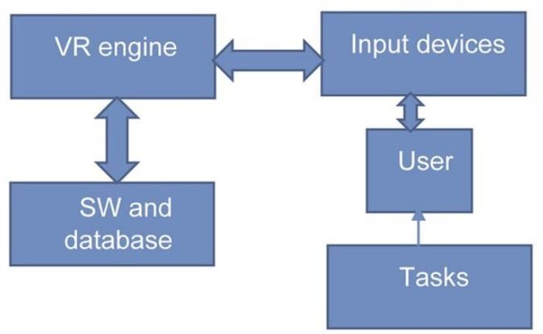

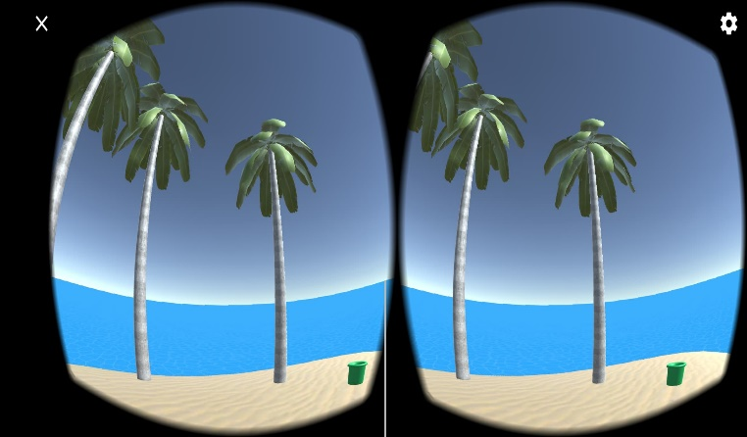

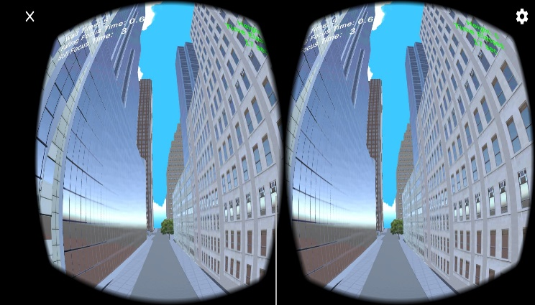

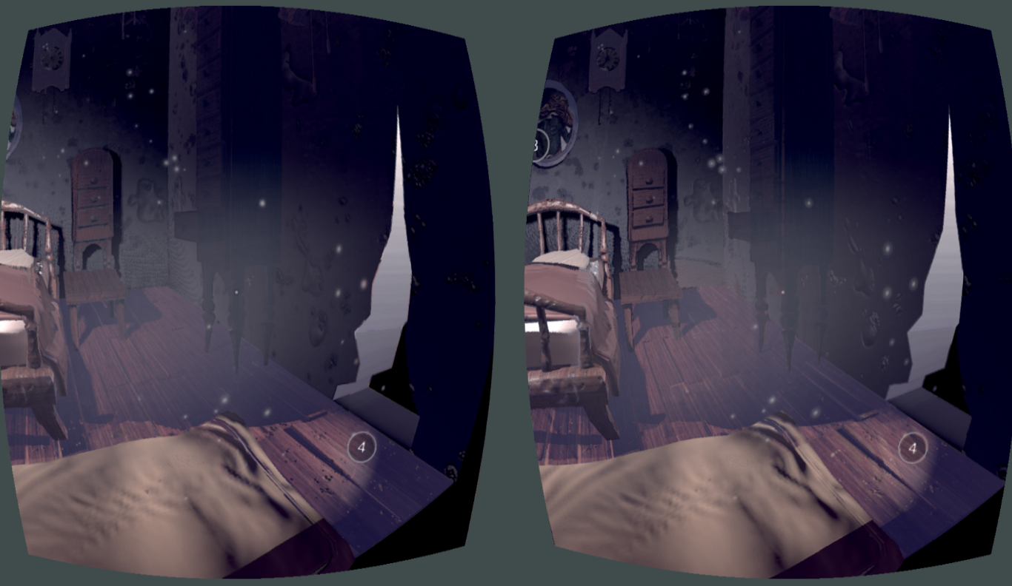

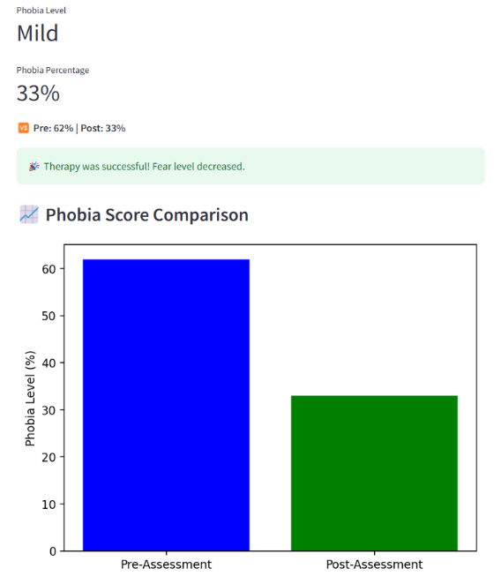

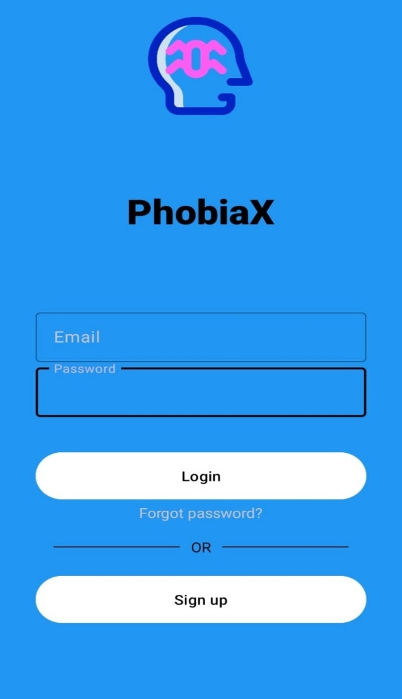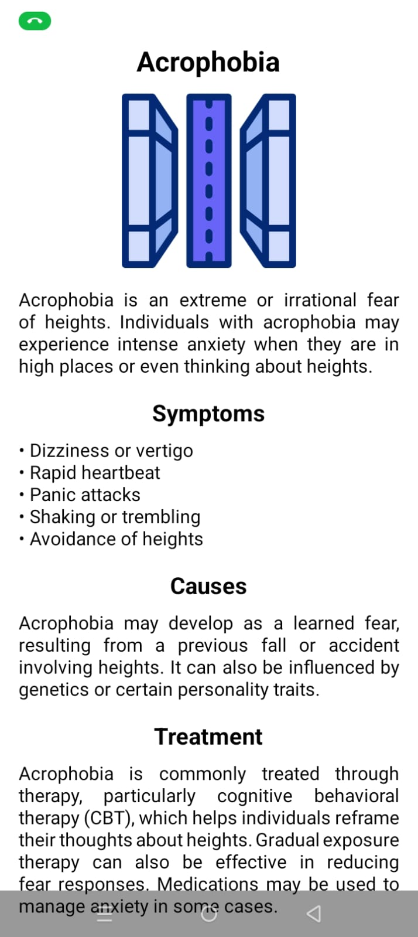

**Turnitin Report**

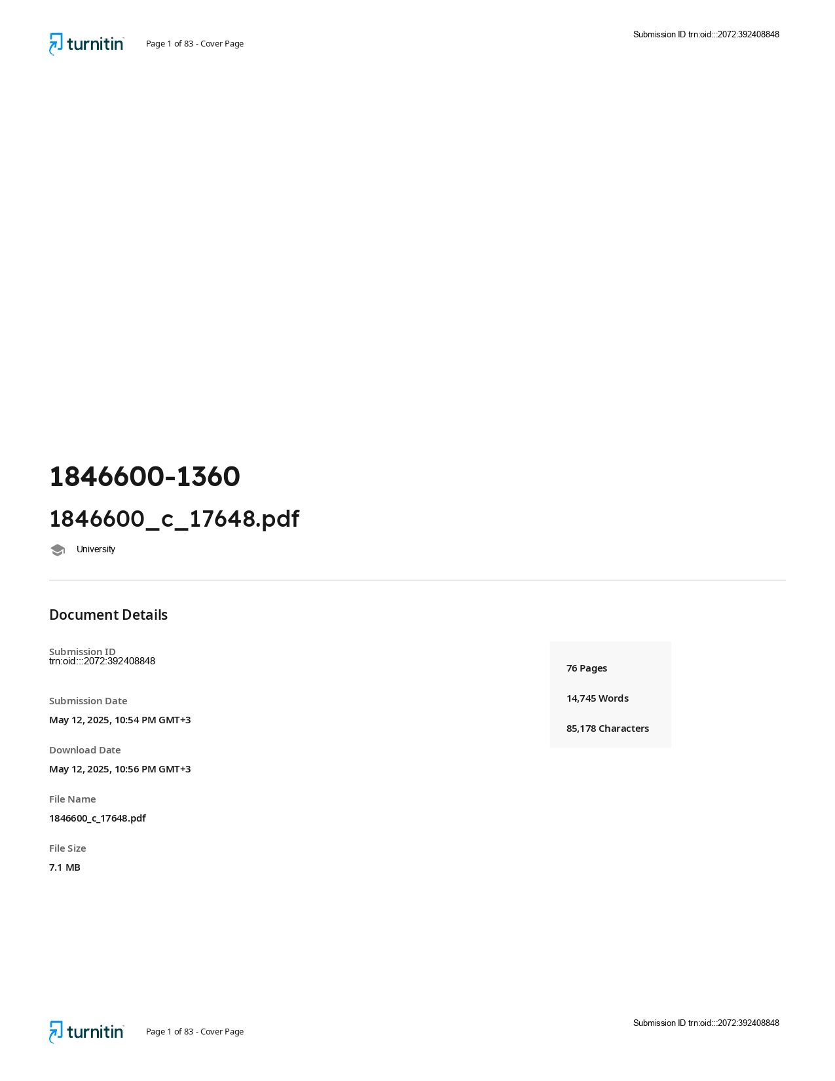

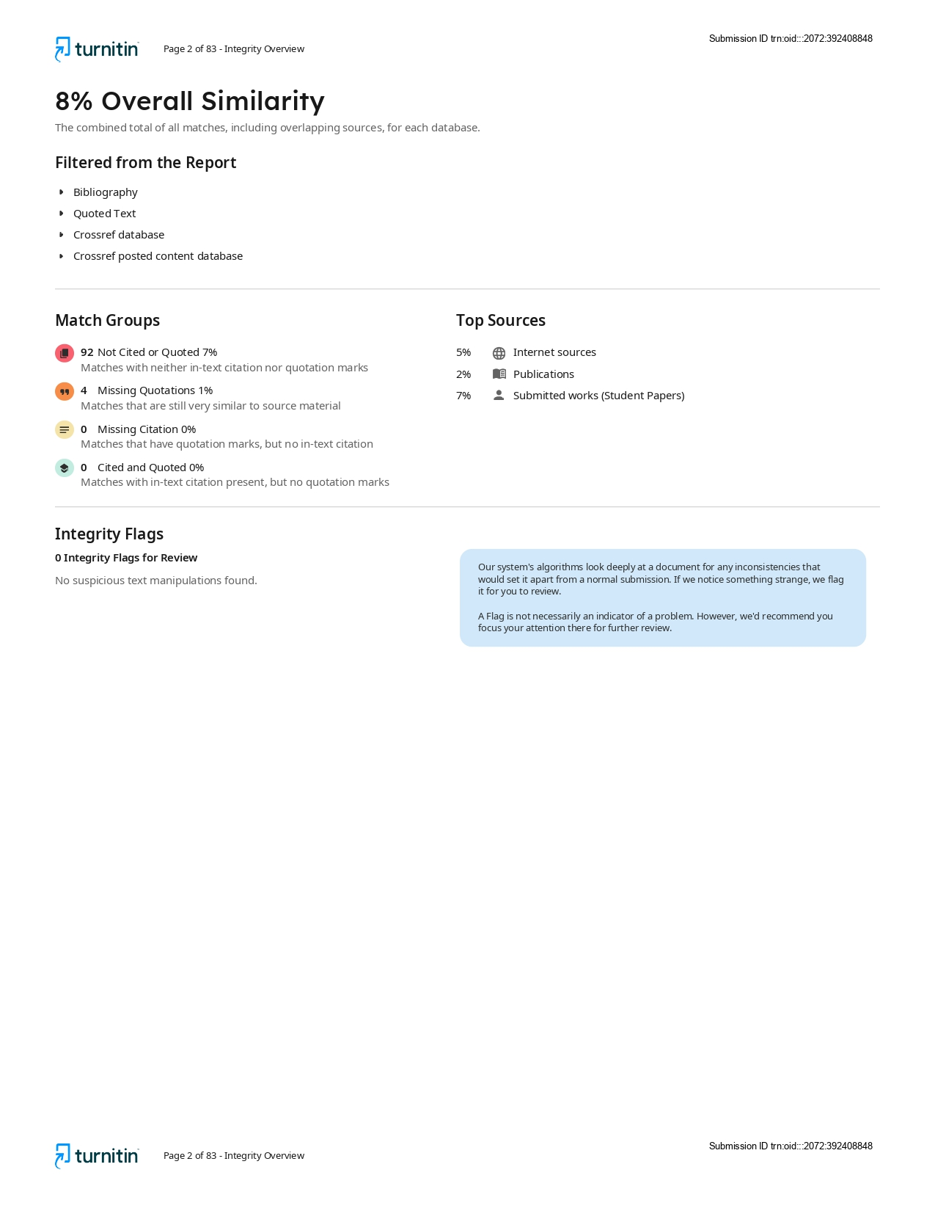

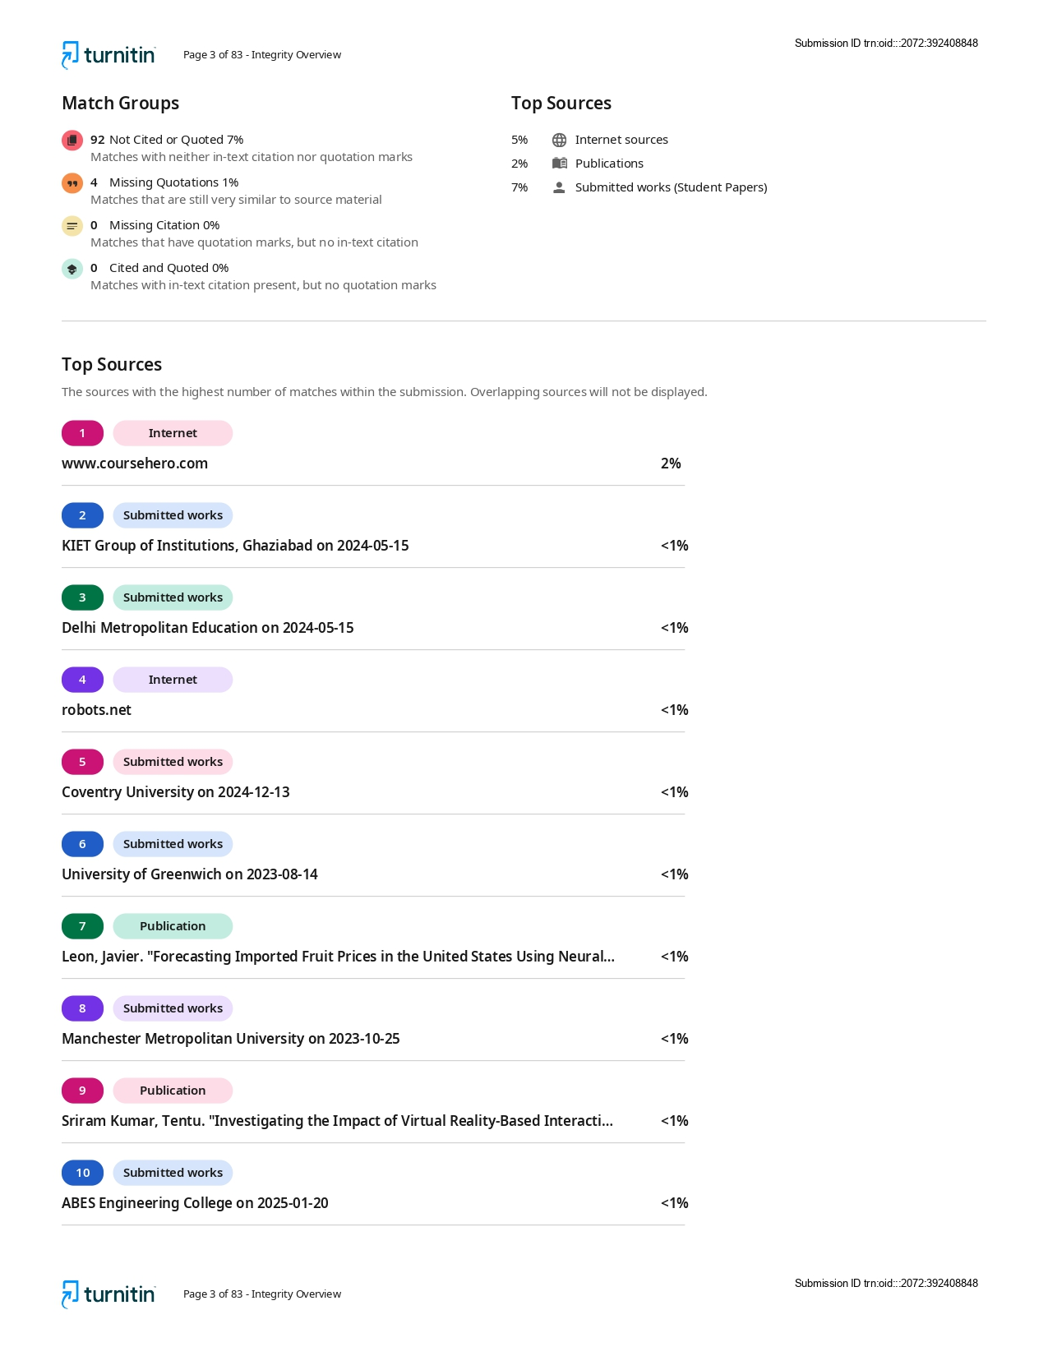

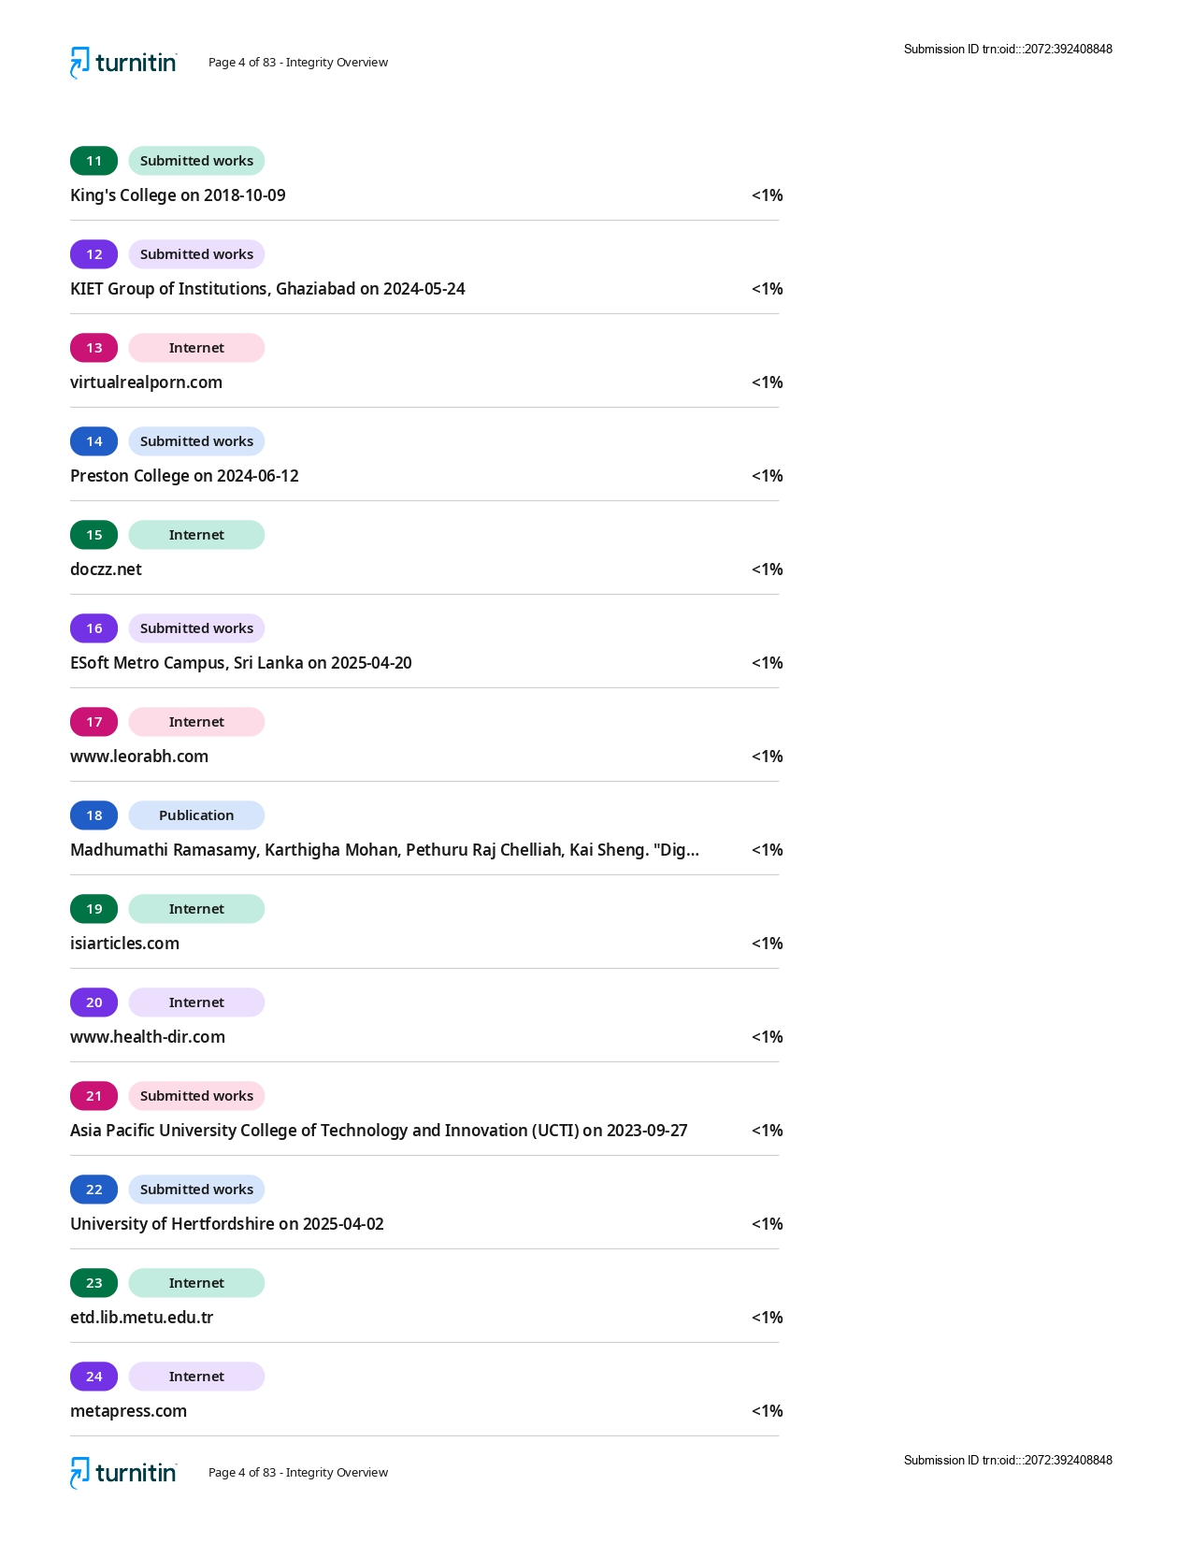

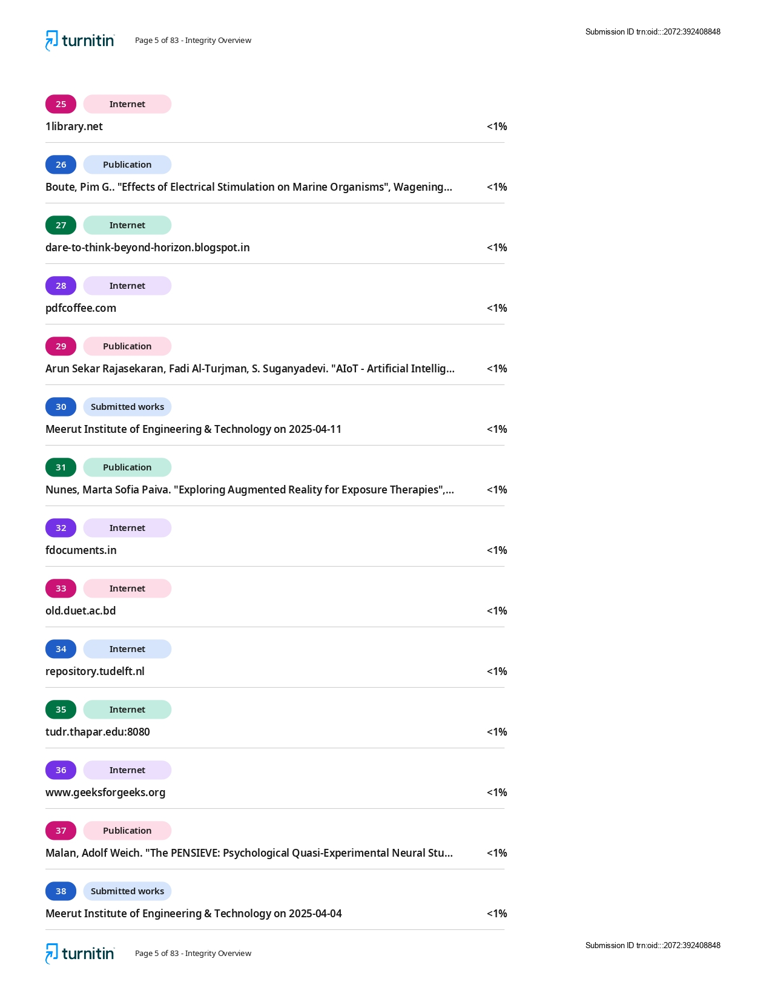

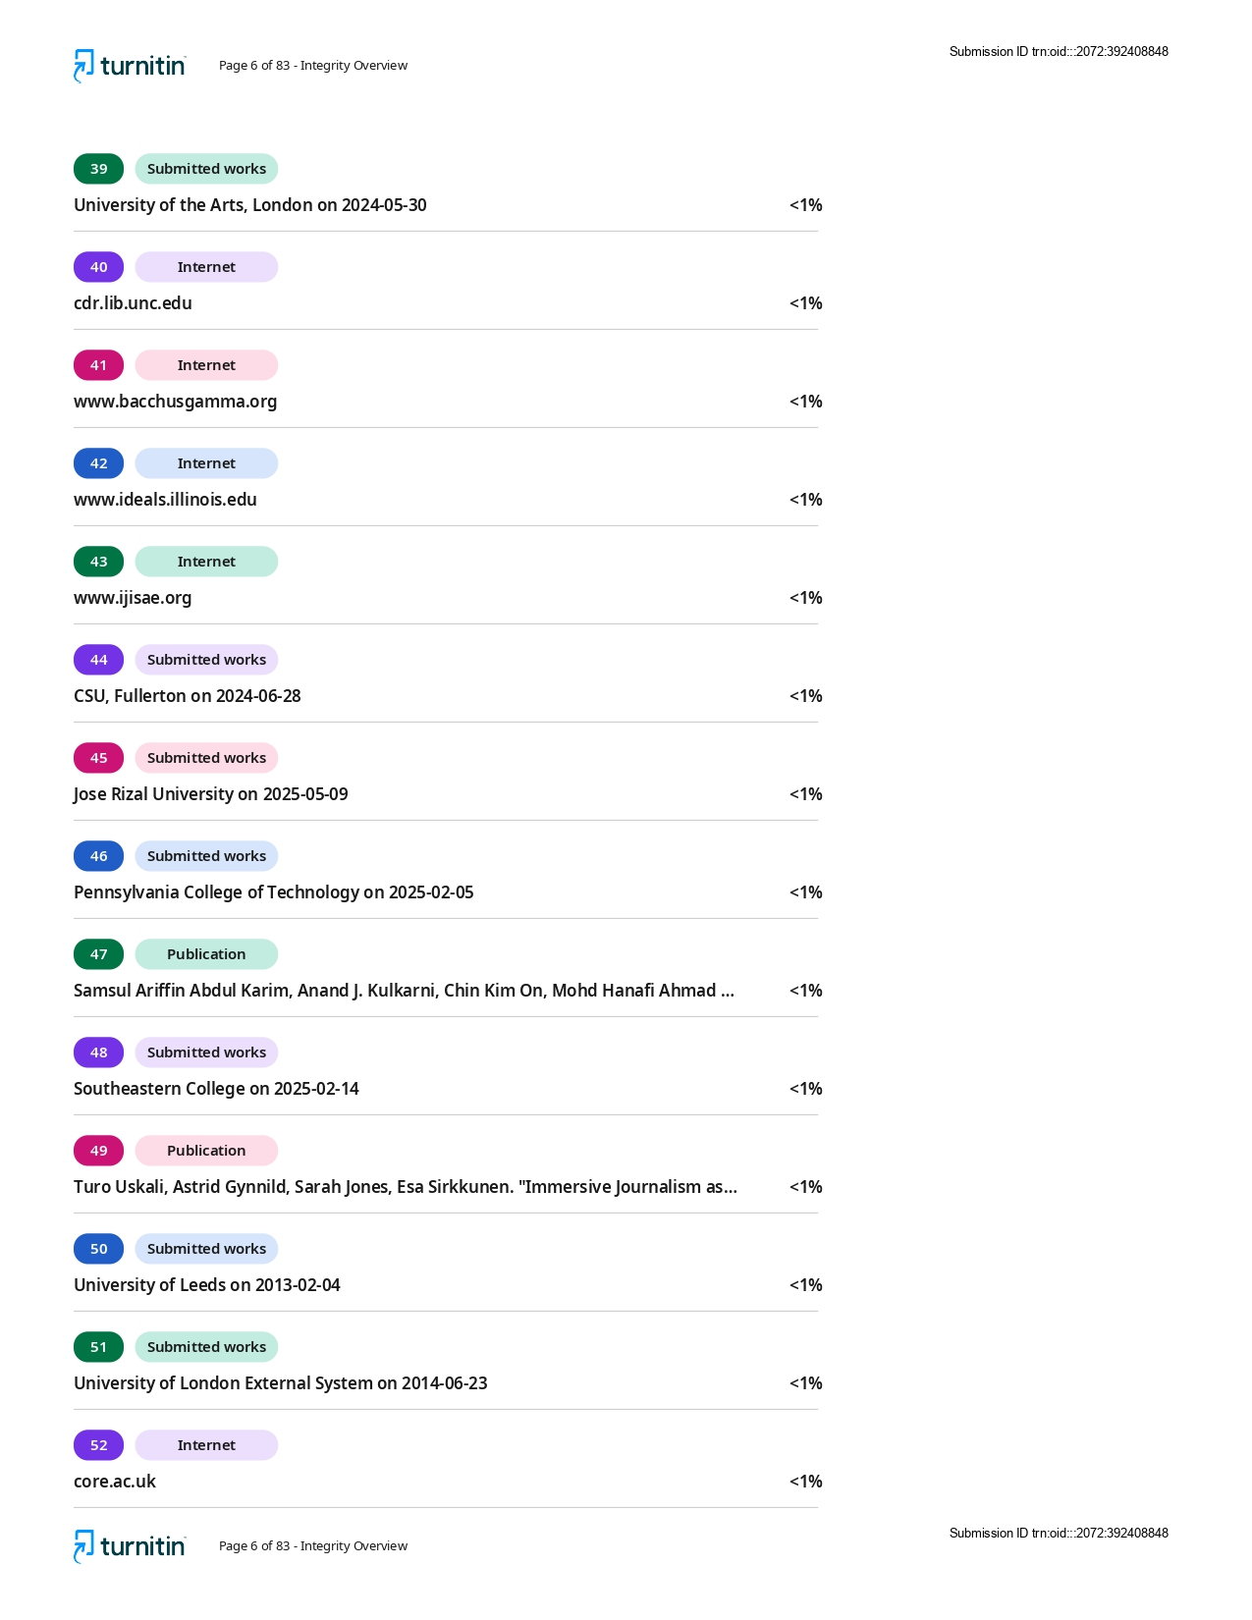

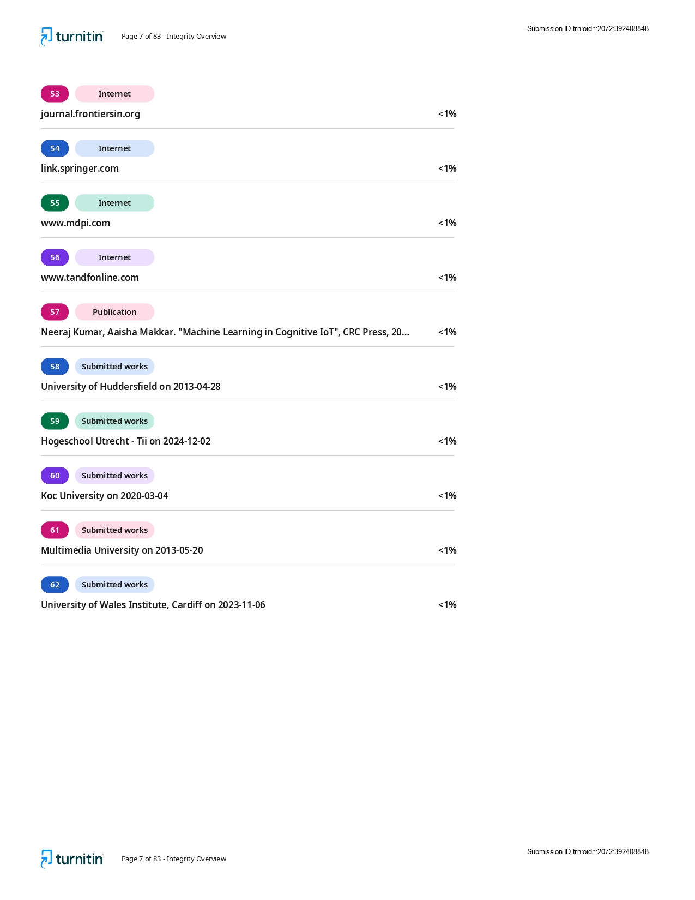

**Research Paper with Turnitin Report**

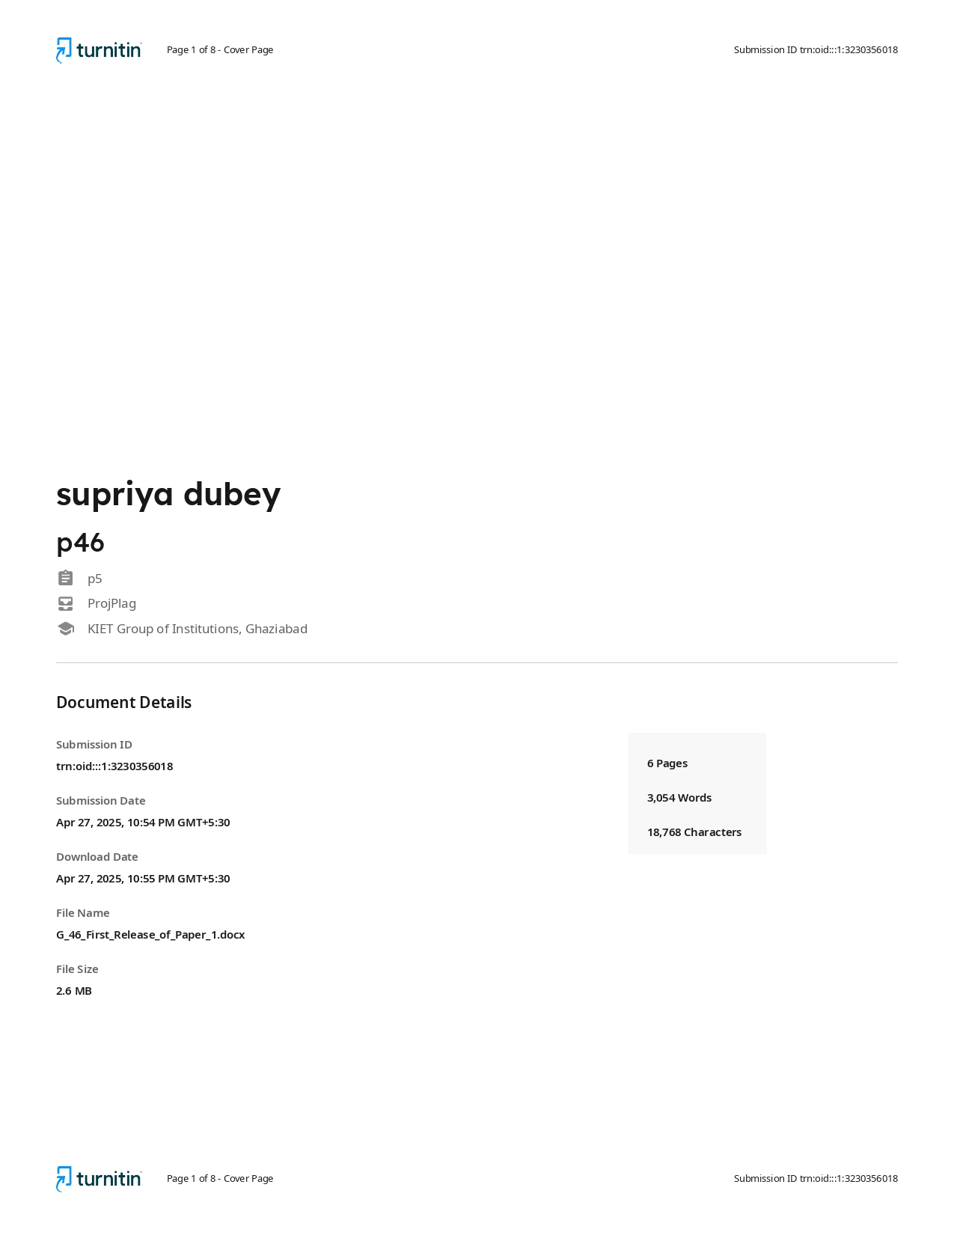

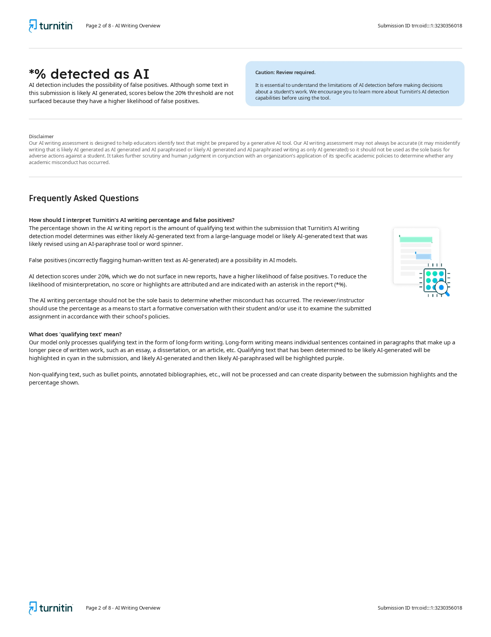

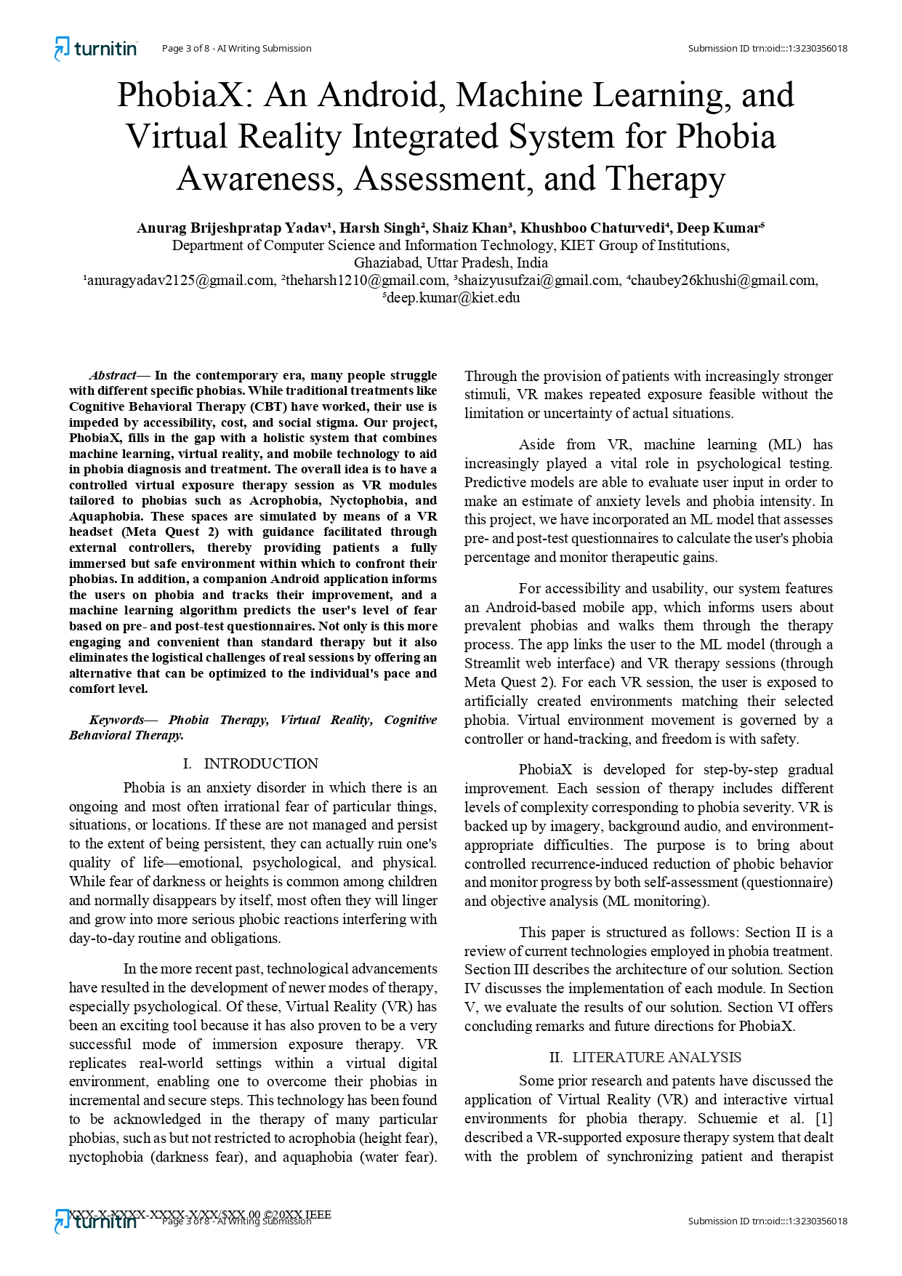

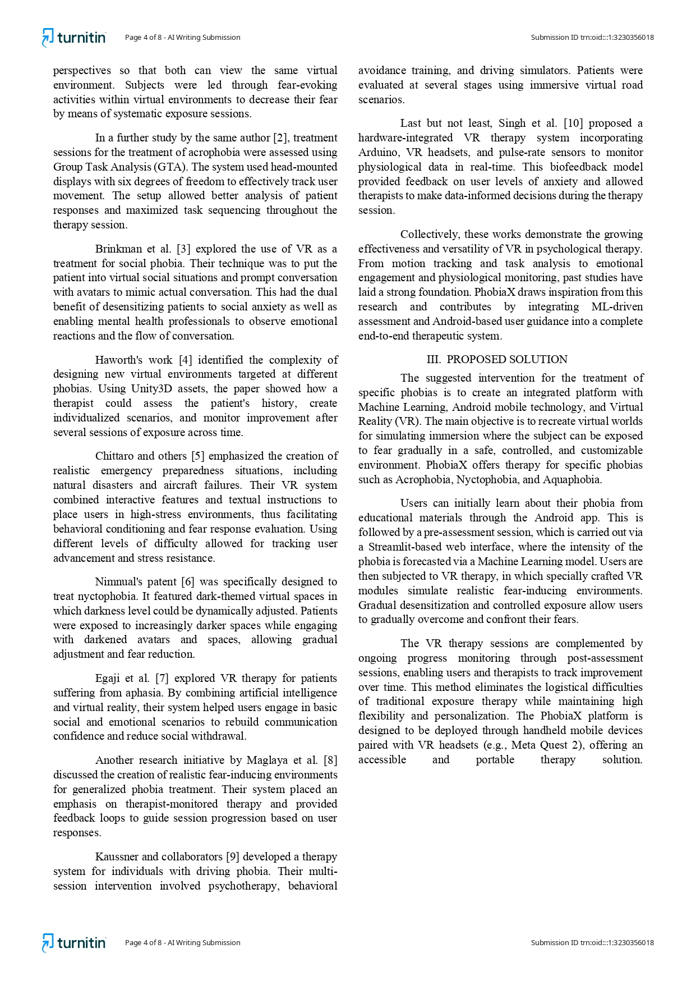

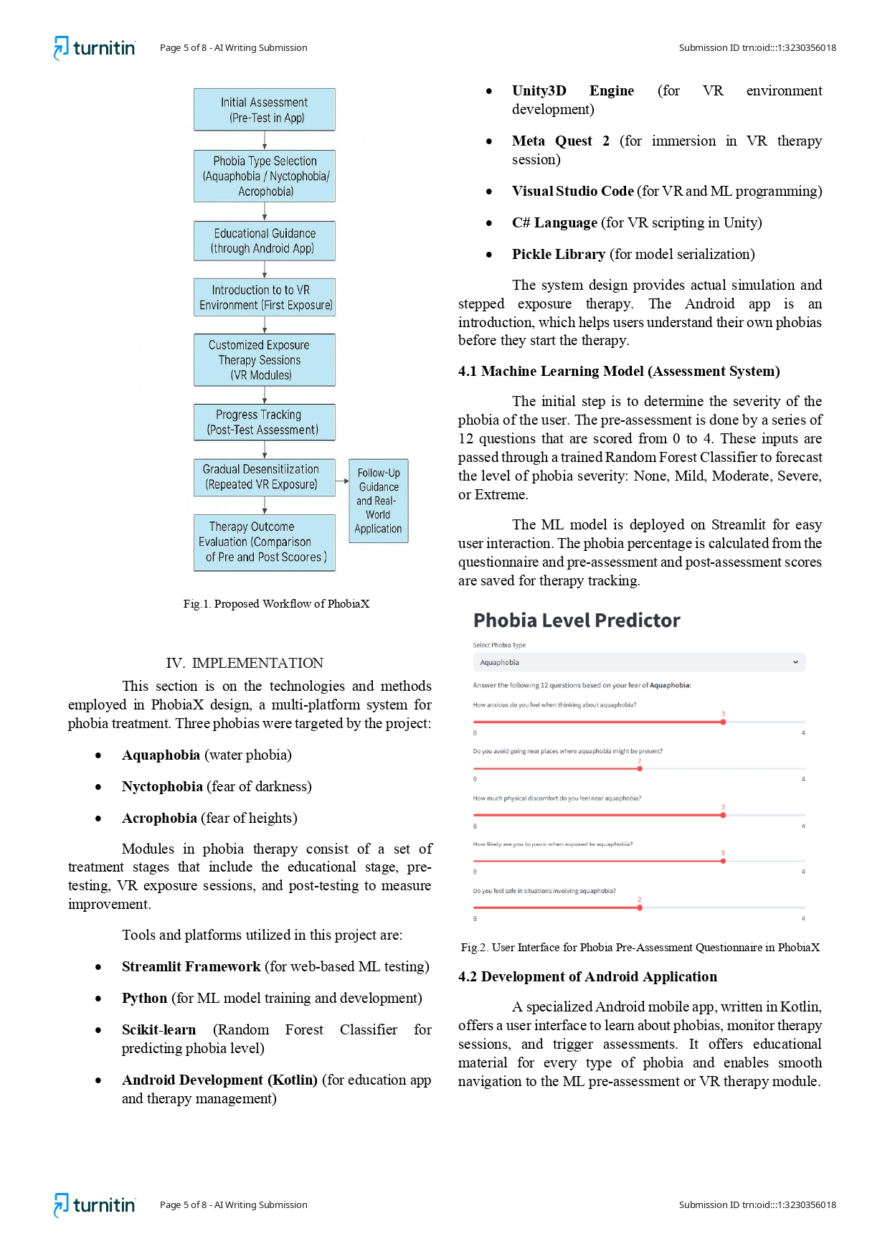

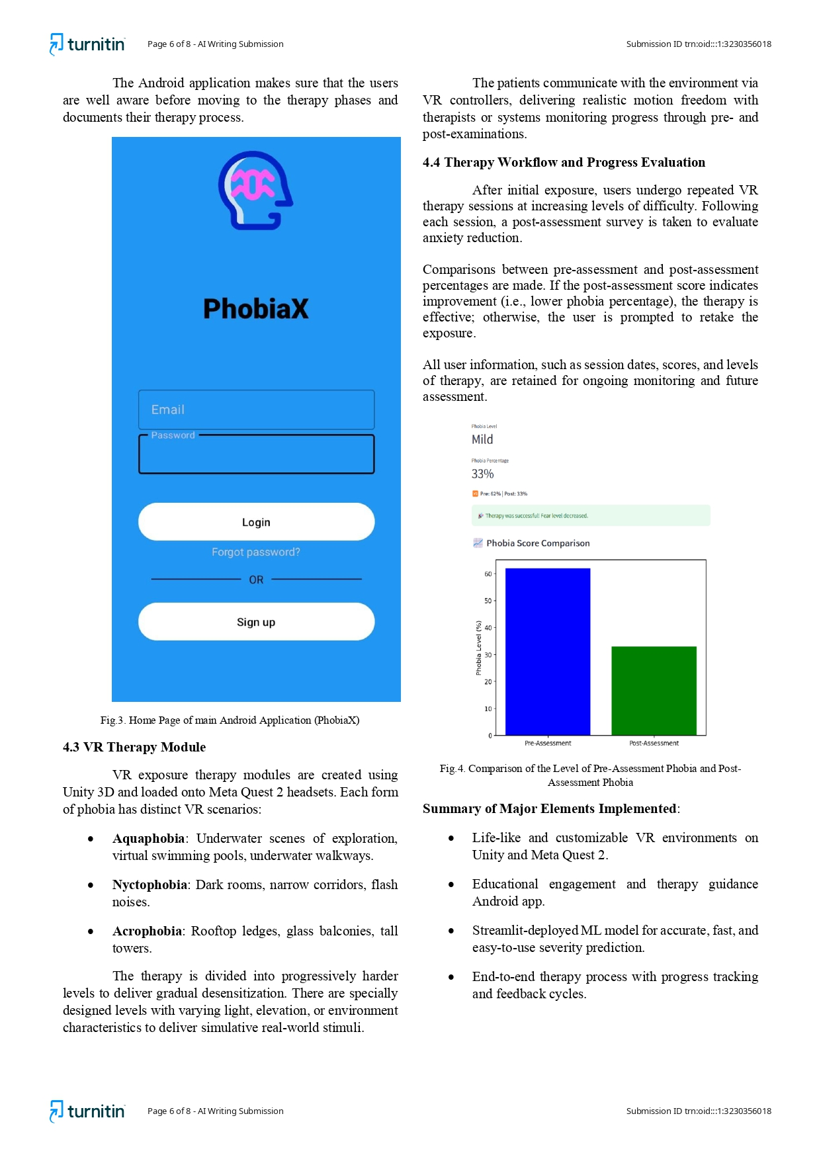

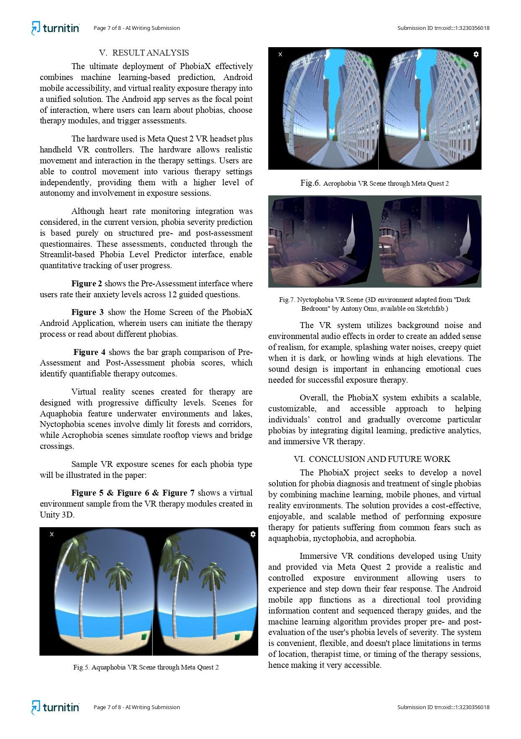

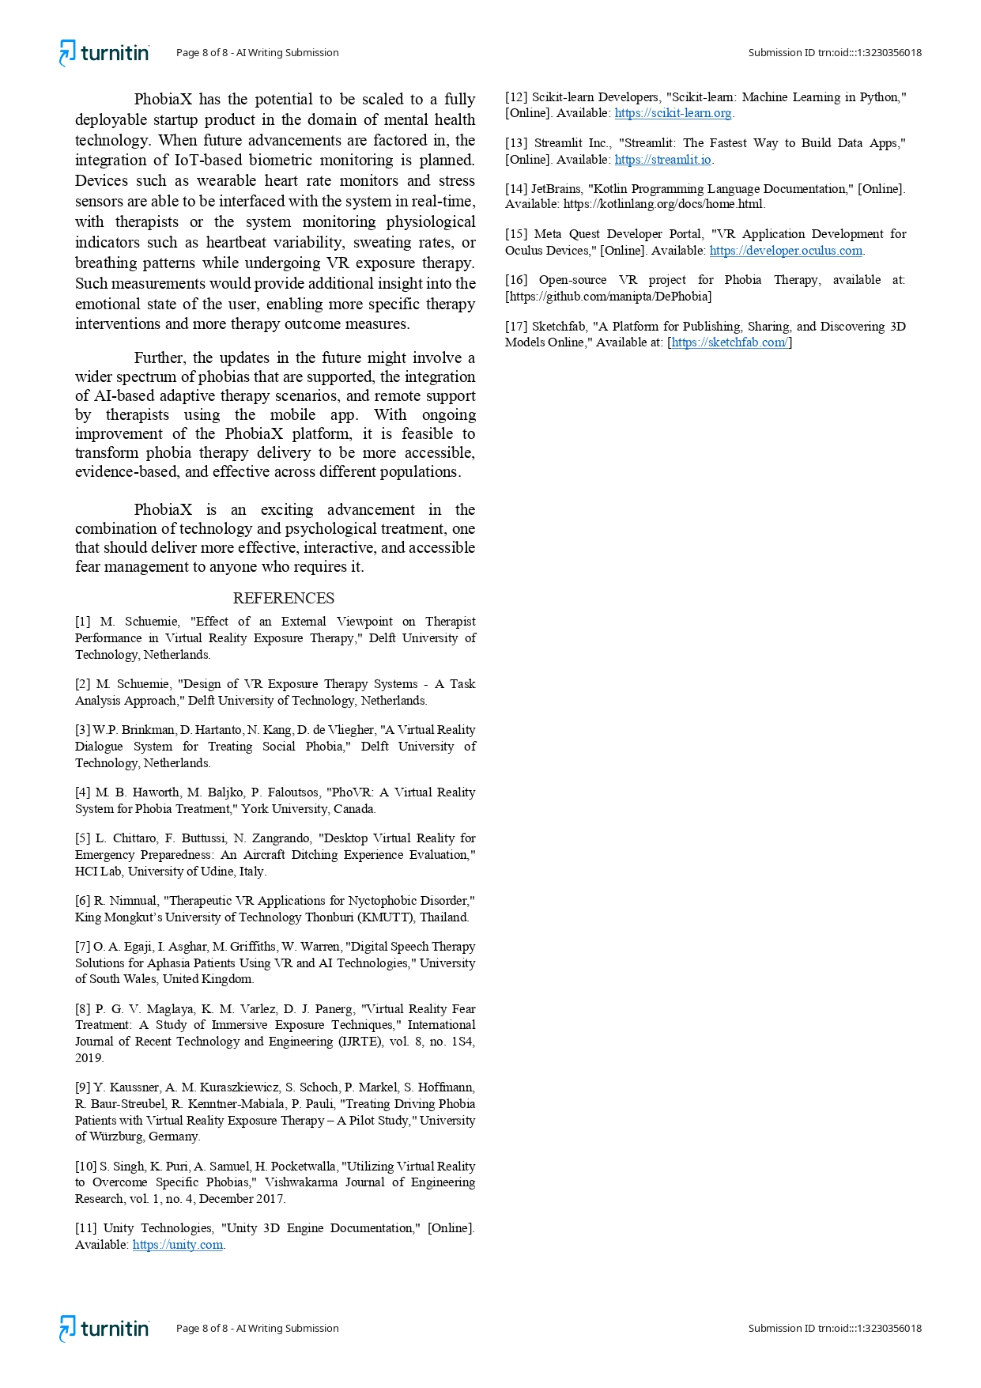







**Proof of Communication/Acceptance**

